Annual Report
2022

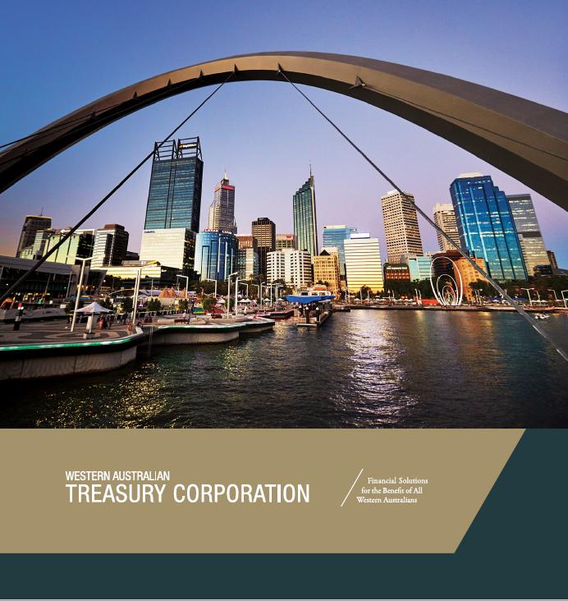

Contents

Overview
Statement of Compliance 3
Vision, Objectives and Values 4
Highlights of 2021–22 5
Chairperson and CEO's Report 6
Performance Against Targets 8
Board of Directors 12
About WATC 14

Agency Performance
Providing Value to Clients 16
Successful Financial Management 24
Optimising Our Performance 32

Disclosures and Legal Compliance
Managing Our Information Assets 36
Our People 39
Board of Directors’ Governance 44
Board Committees 46
Legislation 47
Corporate Governance 48

Financial Statements
Statement of Comprehensive Income 51
Statement of Financial Position 52
Statement of Changes in Equity 53
Statement of Cash Flows 54
Notes to the Financial Statements 55
Certification of Financial Statements 97
Key Performance Indicators 98
Independent Auditor’s Report 102
Client Authorities 107

Contact Details
Western Australian Treasury Corporation 50
Registry Information 50

About This Report
This annual report provides information about the services and performance of Western Australian Treasury Corporation and includes audited financial statements and performance indicators for the financial year ending 30 June 2022. A full copy of this annual report, along with previous years’ annual reports, is available in pdf and other formats on our website www.watc.wa.gov.au.

Acknowledgement of Country
We acknowledge the Traditional Custodians throughout Western Australia and their continuing connection to land, waters and community. We pay our respects to all Aboriginal peoples and their cultures, and to elders both past and present.

Cover photo courtesy of Tourism Western Australia.

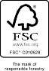
Printed on paper that contains 100% recycled fibre and is FSC® Mix Certified, which ensures that pulp is derived from well-managed forests and recycled wood of fibre. Manufactured by an ISO 14001 certified mill.

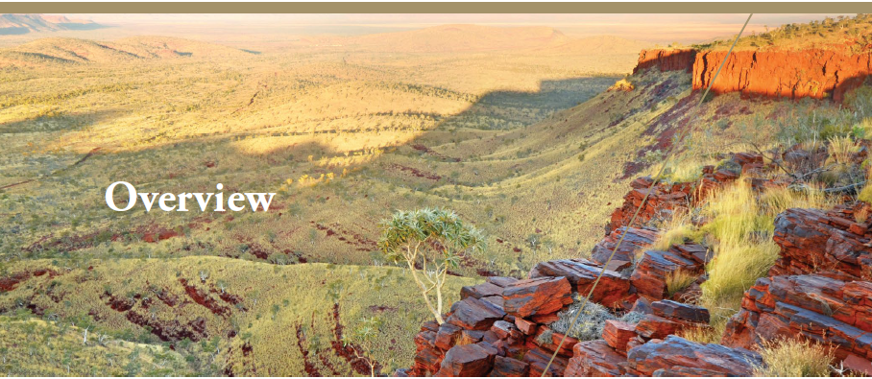

To the Honourable Mark McGowan BA LLB MLA

Premier; Treasurer; Minister for Public Sector Management; Federal–State Relations
In accordance with Section 63 of the Financial Management Act 2006, we hereby submit for your information and presentation to Parliament, the Annual Report of the Western Australian Treasury Corporation for the financial year ending 30 June 2022.
The Annual Report has been prepared in accordance with the provisions of the Financial Management Act 2006.
Yours sincerely,

M J R COURT K P GULICH PSM
CHAIRPERSON CHIEF EXECUTIVE OFFICER

WESTERN AUSTRALIAN WESTERN AUSTRALIAN
TREASURY CORPORATION TREASURY CORPORATION

24 August 2022 24 August 2022

Vision, Objectives and Values

Western Australian Treasury Corporation (WATC) is the State’s central financial services provider, working with our public sector clients to achieve sound financial outcomes.

Vision To be recognised as the best at providing financial solutions for the benefit of the Western Australian public sector.

Objectives In fulfilling WATC’s role as the central financial services provider for the State, our strategic focus for 2021–22 centred on the following key strategic objectives:
- Provide high-quality, cost-effective products and services to the Western Australian public sector.
- Maintain ready access to domestic and international capital markets to ensure funds are raised to finance client borrowing needs.
- Optimise the performance of WATC in accordance with the Western Australian Treasury Corporation Act 1986 and the risk appetite of WATC’s Board.

Values WATC adheres to transacting all business in accordance with our corporate values of:
Integrity
We are open, honest and accountable. We adhere to the highest professional and ethical standards. We honour our promises.
Partnership
We work collaboratively with our clients and colleagues towards achieving successful outcomes.
Adaptability
We challenge ourselves to think creatively and to continuously improve.
Achievement
We are engaged and focused on delivering valued outcomes for Western Australia.
Leadership
We use our knowledge and experience to contribute to the long-term benefit of Western Australia.

Highlights of 2021–22

70%  Staff Engagement  Significantly improved staff engagement, reflecting our continued focus, initiatives, and strategies to support and enable our staff.  See page 40. | $47.8 billion  Client Debt  We successfully managed and delivered on all client borrowing requirements during a year of heightened market volatility. See page 16.
100%  Client Satisfaction  We continued to deliver high-quality, cost-effective financial solutions. Our Advisory Services team contributed their expertise to 53 projects for 32 clients. See page 18. | $446.1 million  Client Foreign Exchange  We transacted in 11 currencies on behalf of 20 clients and assisted in effectively managing their foreign exchange risk. See page 20.
Return of  the AAA  Credit Rating  S&P Global Ratings reinstated Western Australia’s AAA credit rating, which was “supported by Western Australia’s track record of robust financial management, a very high-income economy, and exceptional liquidity”. See page 28. | $5.5 billion  Client Funds Managed  We successfully managed five client investment portfolios in accordance with approved policy frameworks. See page 22.
450+ Building Knowledge
We engaged with over 450 client contacts through our education and training programs, industry forums and economic presentations. See page 21.

ESG Credentials  Promoting Western Australia  We produced, in partnership with an  intra-government working group, the inaugural Environmental, Social and Governance (ESG) Information Pack, to showcase the State’s current and planned ESG-related projects and initiatives. See page 29. | Sustainable Lending  Supporting Local Government  We updated our lending framework to ensure our lending practises continue to be responsible and appropriate, supporting the financial sustainability of the sector. See page 17.

Chairperson and CEO's Report

Adding to the roller-coaster ride of previous years, 2021–22 was another year of significant swings and roundabouts. It is pleasing to note that with agility and responsiveness, the WATC team met the considerable challenges that emerged, continuing to support the needs of the State and deliver value to clients.

Western Australia’s management of COVID-19 was effective in reducing the spread of the virus during the first half of the year, allowing time for the State to run its vaccination programs, and prepare for opening its borders and easing travel restrictions. However, by early 2022 the State moved to a new phase in the pandemic, which coincided with the national spread of the Omicron variant. Supporting our workforce and clients through the transition to living with COVID-19 has been a major priority for us.
The up and down nature of the year was reflected in financial markets. The 10-year yield ranged from a low of 1.37 per cent (20 August 2021) to a high of 4.68 per cent (17 June 2022). More recently, we have seen this same volatility unfold through currency exchange rates with the Australian dollar trading between a low of US$0.6856 and a high of US$0.7579, and all within a month.
The trend of exceptional activity from central banks continued throughout 2021–22. The Reserve Bank of Australia (RBA), through its yield curve control and quantitative easing programs, held approximately 15 per cent of WATC debt at 30 June 2022. However, during the year the RBA started its tightening cycle. Firstly, the yield curve control target was officially discontinued in November 2021, and a cease in bond purchasing soon followed. Then began the increase of interest rates. During 2021–22, the cash rate target was increased from 0.10 per cent to 0.85 per cent. As we all know, this trend continued into the new financial year.
The RBA’s action was in response to a significant swing in global economic activity and sentiment throughout the year. Central banks and policy makers around the world quickly pivoted to tackle rising inflation amidst COVID- era support measures. The invasion of Ukraine by Russia heightened the global supply chain challenges, with movements in oil prices being the most obvious reflection of this. The Brent crude oil spot price ranged between US$64.77 per barrel (20 August 2021) and US$133.89 per barrel (8 March 2022), before closing at US$115.04 on 30 June 2022.
Iron ore was not immune from the year’s volatility, experiencing a difference of US$137 per tonne between the high and low. Despite this volatility, the State achieved strong fiscal outcomes through conservative budget forecasts and robust revenue growth. The State continued to deliver an operating surplus into 2021–22. Across the forward estimates, net debt is forecast to peak at 9.9 per cent of Gross State Product in 2024–25. The resilience of the Western Australian economy was recognised by S&P Global Ratings, which upgraded the State’s credit rating to AAA in June 2022.
Over the financial year, WATC issued
$4.2 billion in benchmark bonds and floating rate notes to refinance existing maturities as the State moved to fund its asset investment from cash surpluses, and repay debt.
The ongoing management of key balance sheet metrics saw debt maturing within 12 months of 16.5 per cent and, reflecting the strong liquidity in the public sector, liquid asset portfolio cover of 219.5 per cent. These were comfortably within our Board’s targets (less than 20 per cent and above 100 per cent, respectively).

When COVID-19 travel restrictions eased, WATC took the opportunity to reengage in person with onshore and offshore investors. These meetings coincided with the return of the State’s AAA credit rating, which further supported the positive Western Australian story we were sharing with investors.
Environmental, social and governance (ESG) considerations for investors continued to grow in momentum during the year. WATC coordinated a working group of 24 government agencies to consolidate information on the State’s current and planned ESG-related projects and initiatives. This culminated in November 2021 with the Premier’s release of the inaugural ESG Information Pack to help inform existing and prospective investors of the State's ESG profile, now and into the future.
On an operational front, our workforce has been exceptionally busy. We have focused on achieving process and system efficiencies through our new treasury management system, together with other information and communications technology reforms, and reviewing our lending framework for the local government sector. We have also farewelled a number of valuable, long-term WATC staff, who are hopefully enjoying a well-deserved retirement. The swing of this is that we have been able to welcome many new faces to WATC, who will help us grow into the future.
Our client-focussed teams continued to share WATC’s knowledge and experience to support a large number of Western Australian public entities across a wide range of advisory engagements. A central theme for the year has been supporting education and training, with over 450 clients attending WATC sponsored educational and training programs, industry forums and economic presentations.
We expect the year ahead to continue the roller- coaster ride as we operate in volatile markets, amplified by the current global uncertainty. Ongoing access to markets to support the objectives of the State Government will remain the key priority, as well as managing risk, maintaining investments in a more challenging credit environment, and supporting clients through material and complex projects.
A big thank you to all our people, whose hard work and dedication to achieving great outcomes remains our core strength. Thank you to our clients who have been flexible and responsive as we have sought to meet their funding needs during what have been, at times, uncertain conditions. And thank you to our financial market partners for their ongoing engagement, support and willingness to understand the ‘WA Story’. Finally, our gratitude to our Board, auditors and other suppliers who have contributed to another successful year of WATC delivering financial solutions to Western Australia.

M J R COURT K P GULICH PSM
CHAIRPERSON CHIEF EXECUTIVE OFFICER

WESTERN AUSTRALIAN WESTERN AUSTRALIAN
TREASURY CORPORATION TREASURY CORPORATION

24 August 2022 24 August 2022

Performance Against Targets

To ensure that WATC achieves its objectives, our Board, with the agreement of the Premier, sets our annual performance targets. These targets are challenging and, when attained, ensure real benefits are delivered to our clients and the State.

Key Performance Indicators
Performance targets form part of our Statement of Corporate Intent, which is submitted to the Premier at the start of each financial year in accordance with Section 16I(1) of the Western Australian Treasury Corporation Act 1986.

Estimated Interest Rate Savings
We aim to deliver value to our clients and the State.

Target | Savings > 0.00%
Result | Savings > 0.00%
Five-Year Trend | 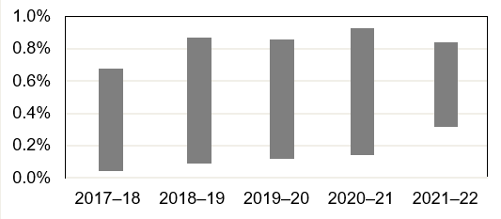

Outcome:
Target Achieved: Through centralising the management of the State’s debt we continued to deliver significant interest rate savings to our clients and the State. The range of estimated interest savings are shown in the graph. See page 98 for more details.

Client Satisfaction
We strive to be the best at providing financial solutions for our public sector clients.

Target | 90% Client Satisfaction  (with an aspirational target of 100%)
Result | 100% Client Satisfaction
Five-Year Trend | 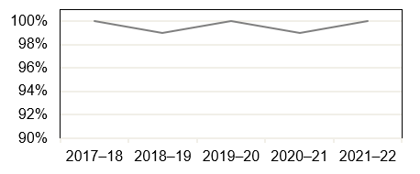

Outcome:
Target Achieved: WATC continued to deliver valued financial solutions to clients. Feedback received from clients who engaged with our advisory services was very positive. One hundred per cent of clients surveyed were very to extremely satisfied with the quality of advice we provided, the value we added to their project, our overall capability, and the service we provided.

Administration Cost Ratio
We are committed to delivering high-quality products and services while still being cost effective.

Target | Administration Cost Ratio < 0.050%
Result | Administration Cost Ratio = 0.039%
Five-Year Trend | 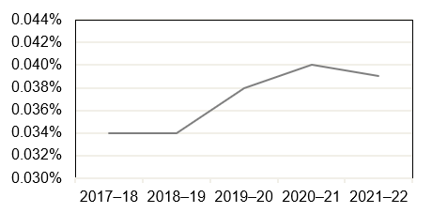

Outcome:
Target Achieved: WATC continued to deliver scale benefits to the State by keeping net administration expenses in check. See Key Performance Indicator section on page 100 for a more detailed explanation.

Performance Against Targets (continued)

Pre-Tax Profit
We aim to maintain an adequate profit while delivering cost-effective products and services.

Target | Profit = $32.9 million
Result | Profit = $25.0 million
Five-Year Trend | 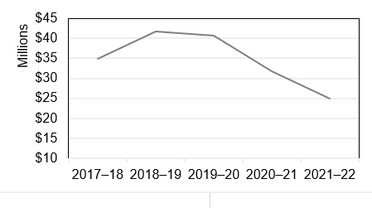

Outcome:
Target Not Achieved: Lower than anticipated new borrowings reduced the administration margin collected, and the lower interest rate environment reduced interest earned on investments. While reducing WATC’s profit, these reflect good outcomes for the State and Western Australian public sector agencies.

Staff Engagement Rating
We strive to create an environment where all staff are encouraged and supported to do their best.

Target | Staff Engagement Rating > 65%
Result | Staff Engagement Rating = 70%
Five-Year Trend | 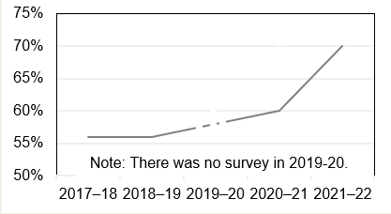

Outcome:
Target Achieved: Staff engagement has significantly improved from previous years’ results. The rating for 2021–22 reflects our continued strategic focus, initiatives and strategies to create an environment that supports and enables our staff to deliver WATC’s vision and objectives.

Five-Year KPI Summary
 | 2021–22 | 2020–21 | 2019–20 | 2018–19 | 2017–18
Estimated Interest Rate Savings > 0.00% | Yes | Yes | Yes | Yes | Yes
Assessment of Client Satisfaction | 100% | 99% | 100% | 100% | 99%
Administration Cost Ratio | 0.039% | 0.040% | 0.038% | 0.034% | 0.034%
Pre-Tax Profit | $25.0m | $31.7m | $40.7m | $41.7m | $34.8m
Staff Engagement Rating* | 70% | 60% | n/a | 56% | 56%
* Methodology used changed in 2017–18.
n/a: not applicable

Five-Year Financial Summary
 | 2021–22  $m | 2020–21  $m | 2019–20  $m | 2018–19  $m | 2017–18  $m
Financial Performance
Profit Before Income Tax Equivalent Expense | 25.0 | 31.7 | 40.7 | 41.7 | 34.8
Financial Position
Total Assets | 51,207.9 | 61,892.2 | 64,658.5 | 59,483.4 | 55,985.8
Percentage Change in Assets (%) | -17.3 | -4.3 | 8.7 | 6.2 | 1.8
Total Liabilities | 51,054.2 | 61,739.3 | 64,506.4 | 59,337.9 | 55,851.3
Equity | 153.7 | 152.9 | 152.1 | 145.5 | 134.5

Board of Directors

The Board, with the agreement of the Premier, sets WATC’s strategic direction and establishes the policies and principles under which we operate.

Michael Barnes PSM
Chairperson
Mr Barnes assumed the role of Chairperson when he became Acting Under Treasurer in the Department of Treasury in 2014. Mr Barnes was appointed Under Treasurer in 2015. As Under Treasurer, he is the principal economic and financial policy adviser to the Government of Western Australia. He is also the Chairperson of WATC’s People and Remuneration Committee. Prior to joining the Department of Treasury in 1997, Mr Barnes worked in the Commonwealth Treasury, where he commenced his career as a graduate in 1992. Mr Barnes holds a Bachelor of Business degree with Honours in Economics, and was awarded a Public Service Medal in the June 2020 Queen’s Birthday Honours for outstanding public service to State government finances in Western Australia.

Michael Court
Deputy Chairperson
Mr Court was appointed to the Board as Deputy Chairperson in July 2017. Mr Court was appointed Deputy Under Treasurer in September 2016, which followed more than five years as the Executive Director of the Department of Treasury’s Economic business unit. Mr Court joined the Department of Treasury in 1997, after working in the Department of Foreign Affairs and Trade, the Commonwealth Treasury and the London Underground Ltd. Mr Court is currently a member of the Bankwest Curtin Economic Centre Advisory Board.

Kaylene Gulich PSM
Chief Executive Officer
Ms Gulich commenced as CEO of WATC in February 2019. Ms Gulich has extensive experience in public policy, knowledge of financial markets and expertise in the Western Australian economy. Ms Gulich has previously held senior roles within the Department of Treasury, as both the Executive Director of the Economic business unit and the Executive Director for Infrastructure and Finance. As well as being a member of CPA Australia and the Australian Institute of Company Directors, Ms Gulich has previously been a Director with Gold Corporation, and is currently a Director on VenuesWest’s Board and the Treasurer for IPAA WA. Ms Gulich was awarded a Public Service Medal in the June 2021 Queen’s Birthday Honours for outstanding public service to Western Australia through a range of roles.

David Brumby
Director
Mr Brumby was appointed as a Director in February 2020. He has worked in wholesale finance for over 30 years across product and relationship areas, both in Australia and overseas. Between 1999 and 2011, Mr Brumby headed Westpac’s Institutional Bank in Western Australia. In 2011, Mr Brumby moved to New York to head Westpac’s Corporate & Institutional Banking business, and between 2014 and 2017, he was the Portfolio Manager/Executive Director for Westpac’s Natural Resources portfolio. Mr Brumby has degrees in mining engineering from the University of Sydney and the University of NSW, and an MBA (IMD). Mr Brumby now runs a dairy farm with his wife, and assists with managing a dairy farm in New Zealand.

Philippa Hobson
Director
Ms Hobson was appointed as a Director in February 2020 and is the Chairperson of the Audit Committee and a member of the People and Remuneration Committee. Ms Hobson is a Risk Consulting Partner at RSM in Perth. Ms Hobson has over 25 years of internal and external audit and risk consulting experience, as well as gaining commercial experience as Finance Manager of a large funds management organisation. Ms Hobson has worked extensively with clients in the public and private sectors, providing audit, enterprise risk management and governance services, internal controls reviews and process redesign, regulatory and financial targeted reviews, and Sarbanes-Oxley control reviews. Ms Hobson’s industry experience covers government, utilities, resources, not-for-profit, financial services and manufacturing. Ms Hobson is passionate about understanding how an organisation’s culture impacts on its performance and conformance.

Susan Murphy AO
Director
Ms Murphy was appointed as a Director in January 2019. As CEO of Water Corporation from 2008 to 2018, Ms Murphy led the multi-faceted organisation that supplies drinking water to two million customers and wastewater services across 2.6 million square kilometres. Ms Murphy played a pivotal role in ensuring sustainable services were maintained during a time of declining rainfall, growing population and scarce water supplies. In each year from 2009 to 2015, Ms Murphy was listed as one of the 100 most influential engineers in Australia by Engineers Australia. Ms Murphy was appointed an Officer of the Order of Australia in 2019 for distinguished service to the natural resources sector in Western Australia, and to engineering.

About WATC

Western Australian Treasury Corporation (WATC) is the State’s central financial services provider delivering financial solutions that benefit all Western Australians. Our principal activities include funding and debt management, asset and investment management, financial advisory services, financial risk management, and treasury management services and systems.

Enabling Legislation
WATC was established on 1 July 1986 under the Western Australian Treasury Corporation Act 1986 (the Act) as the State’s central borrowing authority. Amendments to the Act in 1998 expanded our role to include providing financial management services to the Western Australian public sector.

Responsible Minister
The Honourable Mark McGowan BA LLB MLA: Premier; Treasurer; Minister for Public Sector Management; Federal–State Relations.

Organisational Structure

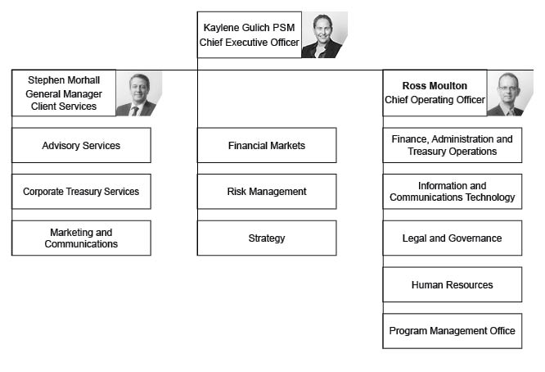

We manage our operations and deliver services through the following functional areas:
- Client Services: Works in partnership with clients to provide a comprehensive suite of high-quality, cost-effective financial products and services in debt finance, investments, foreign exchange, treasury management, financial risk management and advisory services. These products and services are designed to support clients to make informed financial decisions that help them to achieve their objectives, while also realising the overarching goals of the State.
- Financial Markets: Undertakes debt-funding activities in domestic and global capital markets, asset and liability management, management of WATC’s liquidity portfolio, investment management on behalf of clients, foreign exchange management transactions, and economic and financial markets analysis.
- Strategy: Develops and progresses strategic initiatives to improve efficiencies and financial outcomes from a State, client and organisational perspective, in relation to our Financial Markets and Client Services activities.
- Risk Management: Measures and monitors market, credit, operational and liquidity risk to prevent adverse outcomes for WATC, provides guidance to the Executive and Board on all risk matters, and contributes to developing a good risk culture within the organisation.
- Legal and Governance: Administers compliance with legislation, policies and our corporate governance practices, providing oversight of, and guidance in relation to, the origination and documentation of WATC’s borrowings and other agreements, including financial market and client agreements.
- Corporate Services: Supports our operations including the areas of business administrative services, finance, administration and treasury operations, human resources, information and communications technology, marketing and communications, and the program management office.

State Guarantee
Under Section 13(1) of the Act, the financial liabilities incurred or assumed by WATC are guaranteed by the Treasurer on behalf of the State. This guarantee is secured upon the Consolidated Account of the State.

Changes in Written Law
There were no changes to the Act during the 2021–22 financial year.

Ministerial Directives
No ministerial directives were received during the 2021–22 financial year.

Credit Ratings
In line with the State’s credit ratings at 30 June 2022, the debt of WATC is rated as follows:

Rating Agency | Long-Term | Outlook | Short-Term
Moody’s Investors Service | Aa1 | Stable | Prime-1
Standard & Poor’s | AAA | Stable | A-1+

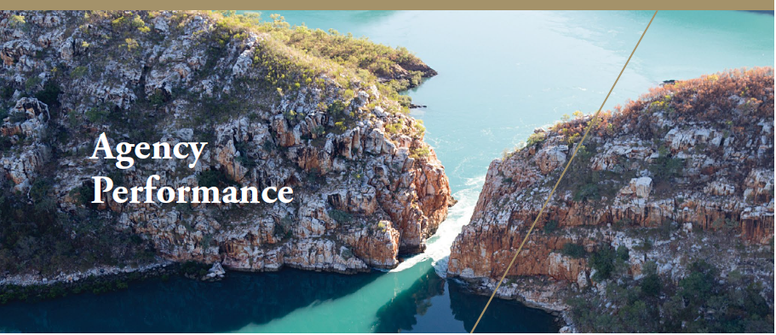

Providing Value to Clients

As the State’s central financial services provider, WATC provides Western Australian government agencies and local governments with a comprehensive range of high-quality, cost-effective financial products and services.

Debt Products and Services

Our Products and Services
We offer a range of high-quality, cost-effective debt products and services to support our clients’ financing requirements, including:

- financing for new social and economic infrastructure projects;
- refinancing existing debt; and
- financing for liquidity management purposes

WATC’s range of flexible debt products cover a wide maturity spectrum and range of structures, offering various repayment options. We work in collaboration with clients to ensure debt products are applied appropriately to achieve each client’s individual ongoing debt and debt management needs, within the overarching State borrowing strategy.

Client Debt
In line with the State's borrowing program that was announced as part of the 2021–22 State Budget, we anticipated and planned for a net $2.1 billion annual increase in client borrowings. However, similar to the previous year, the evolving nature of government initiatives and priorities – coupled with the strength and resilience of the Western Australian economy – has led to client borrowings actually decreasing by $2.2 billion over the course of the year. Total client debt outstanding at 30 June 2022 was $47.8 billion, down from $50.0 billion at the end of 2020–21. For a full listing of client debt outstanding see page 107.

As at 30 June 2022, the total debt outstanding with WATC by Western Australian local governments was $602.9 million, a net increase
of $20.9 million during the 2021–22 financial year. We approved 93 new loans totalling $147.4 million for our local government clients.

WATC Client Debt 1987 to 2022

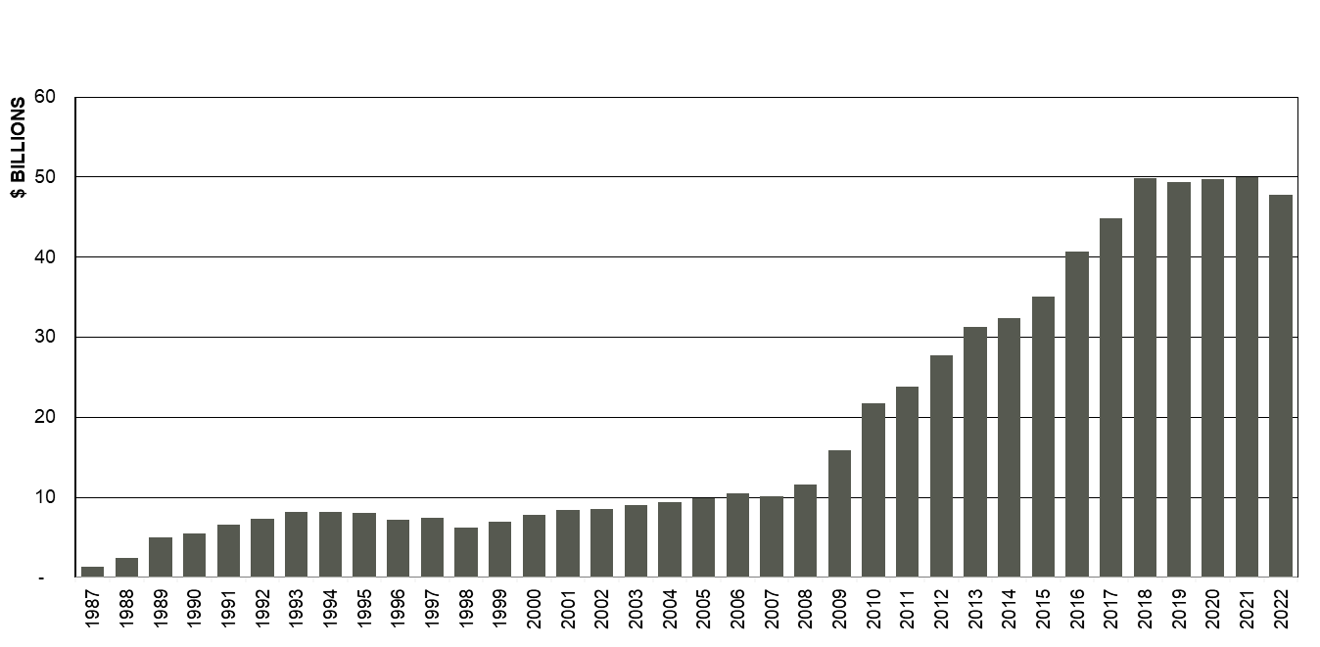

Supporting Local Government Financial Sustainability

Our Commitment
As the primary provider of term debt funding to local governments across Western Australia, WATC supports the financial sustainability of the local government sector and is committed to continuing to lend to local governments in a responsible and sustainable manner.

As part of this commitment, we undertook a comprehensive review of our local government lending framework and implemented a number of improvements to our credit assessment and ongoing governance framework which will take effect on 1 July 2022.

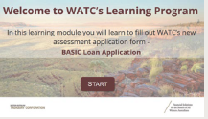
Support and Resources
Our local government clients are being fully supported to transition to our new framework. A number of training resources were developed, as well as a comprehensive communications campaign. This included a series of presentations, webinars, email updates, eLearning resources, frequently asked questions, and articles in the WATC and local government sector newsletters.

Providing Value to Clients (continued)

Delivering on Clients’ Requirements

To ensure we continue to deliver on the requirements of our clients, we have a client-focused key performance indicator that, through independent surveys and direct client feedback, measures client satisfaction. Client feedback completed during 2021–22 achieved 100 per cent satisfaction across a range of measures.

See Key Performance Indicators on page 9 for more details.

Financial Advisory Services

Our Team and Services
Our Advisory Services team provides independent expert advice on corporate and financial risk management. Our services support clients and encourage better-informed financial decision making.

Our team delivers high-quality, easy-to- understand financial analysis, modelling and scenarios to enhance the corporate and financial risk management analyses on client projects, supporting them in their consideration and understanding of the implications of their financial decisions.

We work collaboratively with our clients to ensure better outcomes for both them and for the State. We do so by integrating our expertise, experience and understanding of the State’s public sector with the unique business knowledge of each of our clients.

Client Engagements
This financial year we have continued with, and completed, a number of engagements associated with delivering new State infrastructure that feature complex funding approaches and compliance with Infrastructure Australia processes.
These include:

- Main Roads Western Australia: Agricultural supply chain improvements which involved evaluating initiatives to improve the grain freight transport network in Western Australia.

- Department of Transport: Westport, a multi-billion dollar potential port and logistics project.

We also delivered client engagements on:

- Cost–Benefit Analysis: Calculating the benefit–cost ratio measuring multiple scenarios and cases, which are underpinned by integrated financial models that involve, at times, over one million calculations per scenario.

- Business Case Development Support: Providing workshop facilitation services, assistance in option evaluations and risk mitigation assessments, and guidance on compliance with Strategic Asset Management Framework guidelines.

- Financial Modelling: Developing and validating financial models to provide clients with a clearer vision of current and longer term financial sustainability.

Client Feedback
Following the completion of each advisory service engagement, clients are requested to provide their feedback. As in previous
years, the feedback received for the 2021–22 financial year was extremely positive across all areas. Clients expressed very high levels of satisfaction on the quality of advice provided, the value added to their projects, and our team’s overall capability and level of service.

The effectiveness of our Advisory Services team is also apparent through our client re- engagement levels. Existing clients regularly appoint our team to work on new projects, providing further evidence that we continue to deliver high-quality, cost-effective financial solutions that meet client needs.

Case Study: The Value from the Pawsey Supercomputing Research Centre

Nature of the Engagement
The Department of Jobs, Tourism, Science and Innovation (JTSI) engaged WATC to analyse the value to Western Australia of the State Government’s financial support of the Pawsey Supercomputing Research Centre (Pawsey), whose primary function is to accelerate scientific research for the benefit of the nation.

WATC quantified financial and economic value – both historical and forecast – which Pawsey brings to the State so that value could be contrasted with the State’s investment cost.

About Pawsey
Located in Western Australia, Pawsey is an unincorporated joint venture between Australia’s national science agency CSIRO, Curtin University, Edith Cowan University, Murdoch University and The University of Western Australia, and has one of the most powerful public research supercomputers in the Southern Hemisphere. Pawsey is a significant National Collaborative Research Infrastructure Strategy facility that offers world-class services and expertise in high-performance computing, data storage and visualisation at no cost to researchers. The Centre supports university, industry and government research in key scientific areas such as radio astronomy, bioinformatics, energy and resources.

Improved Client Outcome
Using a benefit–cost assessment framework, WATC was able to estimate the significant value that the State derives from certain quantifiable services and activities provided
by Pawsey. This analysis supported a wider JTSI evaluation of the impact of the State Government’s investment into Pawsey.
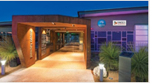
“The economic modelling undertaken by WATC was an important component of our evaluation work. The advice was of high quality and added key value.”
Claire Patterson, Director, Science and Innovation, JTSI

Photo courtesy of Pawsey Supercomputing Research Centre

Providing Value to Clients (continued)

Foreign Exchange Services

Our Products and Services
WATC provides a broad range of foreign exchange products and services that assist clients with identifying and quantifying foreign currency exposures. Working in partnership with our clients, and ensuring they are fully informed of their foreign exchange risks, we design and execute currency management strategies to manage their exposure. This includes assisting clients with managing foreign exchange risk in compliance with Treasurer’s Instruction 826.

As a preferred counterparty in the financial markets, clients benefit from WATC’s direct access to wholesale foreign exchange markets, multi-currency funds settlement systems, dedicated capital market information and treasury management systems. We deliver complete and ongoing client support by providing cash flow projections, audit confirmations, position reporting and market valuations of outstanding transactions.

Client Projects
In addition to delivering value in cost-effective foreign exchange transactions, we worked with clients in an advisory capacity on a number
of interesting projects to help identify, and successfully manage, foreign exchange risk. Some of our clients and their projects included:

- Department of Finance: Pathwest Robotic Instrument Services

- Department of Fire and Emergency Services: Google mapping services procurement

- Public Transport Authority: specialised railway equipment and radio systems

- Synergy: Big Battery Project

- Western Australia Police Force: helicopter and armoured tactical response vehicle procurement, and the Emergency Services Radio Network.

Client Foreign Exchange

During the year, we executed in excess of $446.1 million in foreign exchange transactions in 11 currencies and on behalf of 20 clients. All of these clients benefited from the competitive pricing that we are able to achieve through our scale of operations.

Building Knowledge and Understanding

During 2021–22 we engaged with over 450 client contacts across a range of education and training seminars, industry forums and economic presentations, delivered in either an online or in-person format.

Foreign Exchange Seminars
Six seminars were held promoting awareness and understanding of foreign exchange risk management issues. The seminars ranged from an introductory level providing an overview of foreign exchange, through to more advanced levels covering the use of options, hedging and cash flow risk management.

We also provided procurement master classes which focused on foreign exchange risk management within procurement, how it can arise, risk transfer mechanisms and how best to manage the risk through the procurement process.

Economic Presentations
Two presentations were held where chief economists from major Australian banks presented their views on interest rates, currencies and the economy to our clients and staff.

Industry Events
We hosted clients at five industry events where presentation topics were aligned and relevant to WATC and clients’ roles.

Specialised Financial Training
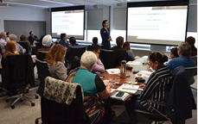
As the State’s central financial services provider, we look for opportunities to deliver relevant, specialised technical training programs that further develop and enhance the understanding of financial risk management across the State’s public sector. This year we facilitated two Financing Large-Scale Investments training programs which were run in collaboration with Macquarie University.

Providing Value to Clients (continued)

Asset and Investment
Management Services

Our Products and Services
WATC assists in managing the finances of the State, and our clients, by providing investment products and treasury management services. These products and services are tailored to suit individual client needs and assist with the management of financial risks, including interest rate and credit risks. We also undertake research and development of investment product opportunities to assist clients in managing their short to medium-term investment needs.

Clients benefit from our considerable experience and expertise, together with the systems, pricing and oversight that come with our scale of operations within the financial markets.

Client Investments Managed
We manage the investment of funds on behalf of the Public Bank Account and the Future Health Research and Innovation Fund, as well as for Landgate and Lotterywest. Total client funds under management at 30 June 2022 was $5.5 billion, across five investment portfolios. Client investment portfolios are managed by WATC in accordance with client approved policy frameworks which include defined risk parameters and performance benchmarks.

At 30 June 2022, we held $113.7 million from clients utilising our overnight cash deposit and term deposit facilities, a substantial increase from the client investments held at 30 June 2021.

We also continued to provide back-office trade capture and reporting of treasury management services for two clients.

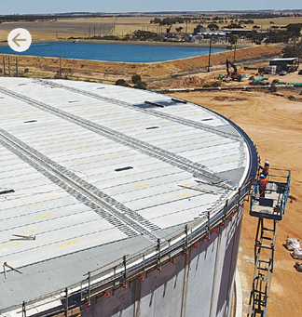
We Enabled…

Water Corporation is progressing projects across the State that improve water quality and deliver a more secure water supply. Enabled by debt funding from WATC, one such project was the construction of a new 42-million-litre water storage tank for the town of Merredin.

Photo courtesy of Water Corporation

Increasing Knowledge on Financing Large-Scale Investments

Following on from the success of WATC’s Financing Large-Scale Investments training program run in collaboration with Macquarie University in 2020, another two training sessions were run during 2021–22. A total of 59 WATC staff and clients have now completed the program.

Program Outline
Adapted from a unit of Macquarie University’s Master of Applied Finance, the two-day program provided an overview of financing large-scale investments and how this differs from standard corporate finance. Attendees learned about the:

- process, techniques and principles required to structure, value and finance large- scale infrastructure and industrial projects, and;

- different ways project finance allocates risks and responsibilities in complex projects and renders them financeable.
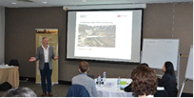

Participant Feedback
Feedback on the program from all participants was very positive and affirmed that the program improved their skills and knowledge.

Building on Our Achievements in 2022–23

We will be working with our clients and investors to implement a sustainability bond framework to finance client initiatives that meet internationally recognised environmental, social and governance (ESG) standards. The framework will complement the Western Australian Government’s ongoing efforts to improve ESG outcomes for the State.

We will continue to work with our clients to support the delivery of key client projects and State initiatives.

Successful Financial Management

To deliver on the State’s borrowing requirements and meet our clients’ evolving needs, WATC continues to be flexible and adaptive – an approach that has been essential for managing increased volatility and uncertainty in financial markets.

Delivering on Clients’ Borrowing Requirements

In sourcing funds to meet client debt financing requirements, we borrow from domestic and international capital markets, both of which continue to be impacted by the ongoing COVID-19 pandemic, increasing inflation and central bank policy tightening cycles.

For us, these impacts were felt principally via increased volatility and higher yields in the financial markets. This was particularly the case in the first half of 2022 as market commentary

fuelled speculation of more rapid and outsized central bank tightening due to inflationary spikes largely caused by rising energy costs and supply chain disruptions.

Our flexible and adaptable approach has meant that despite these challenges and uncertainty, we successfully managed and delivered on all client borrowing, refinancing and repayment requirements during the financial year.

Savings Delivered

To ensure continued effective delivery, we have a key performance indicator (KPI) to measure estimated interest rate savings. This calculation approximates how much clients save when borrowing from us, as compared to the corporate bond market. The KPI was achieved with WATC continuing to deliver interest rate savings estimated in the range of 0.33–0.84 per cent to clients throughout 2021–22.

See Key Performance Indicators on page 98 for more details.

Economic and Market Conditions

The global economy continued to grow strongly in the second half of 2021, however, activity faced increasing headwinds in the first half of 2022. A rapid rebound in demand, the ongoing impact of COVID-19 on global supply chains and sharp rises in commodity prices, exacerbated by the war in Ukraine, have pushed inflation to the highest level in decades, driving central banks to begin aggressively raising interest rates.

The Australian economy has been one of the strongest performers among the developed economies. However, strong demand, tight labour market conditions and supply chain disruptions have pushed Australian inflation to its highest level since the spike following the introduction of the goods and service tax in 2000. The Reserve Bank of Australia (RBA) raised the cash rate by 125 basis points to 1.35 per cent over the course of May, June and July in 2022 – the fastest pace of tightening since 1994. The RBA is expected to continue raising interest rates to drive inflation back to the 2–3 per cent target band.

Central banks, including the RBA, have also ended their quantitative easing programs and announced plans to gradually reduce the size of their bond holdings, which the RBA will achieve by not reinvesting the proceeds of maturing bonds in its portfolio. In addition, the maturity of Term Funding Facility loans is
expected to see a significant decline in the RBA balance sheet over the next couple of years.

Expectations for central bank interest rate increases and the end of quantitative easing have driven a substantial increase in the cost of new borrowing, both in Australia and overseas.

Western Australia’s strong domestic economy and record-high merchandise exports of $242 billion in 2021–22 (46 per cent of the national total) helped drive the State unemployment rate to 3.4 per cent in June 2022 with a participation rate of 69.3 per cent, which is well above the national average.

Western Australia’s strong economic performance sees the State as the only Australian jurisdiction to record an operating surplus and a reduction in net debt in 2021–22.

Financial Market Activities

Flexibility During Uncertainty
Following the release of the 2021–22 Western Australia State Budget in September 2021, we announced our 2021–22 borrowing program which highlighted an estimated $2.1 billion increase in client borrowings.

However, reflecting the strong fiscal position of the State, we saw client borrowing decrease by $2.2 billion over the course of the year.

We Supported…

The Western Australia Police Force’s acquisition of the Mission Mapping System and a forward-looking infra-red camera for its fixed wing aircraft was supported by WATC’s foreign exchange services. This sophisticated equipment is used for aerial law enforcement across Western Australia.

Photo courtesy of Western Australia Police Force

Successful Financial Management (continued)

Adapting to Change
While the repayment of client debt reduced our funding task, WATC was still active across all elements of financial markets and exposed to the volatile market conditions. Despite these challenging conditions, we successfully delivered on all client requirements. During 2021–22 we:

- issued $4.2 billion in benchmark bonds and floating rate notes (FRNs) to refinance maturities during the financial year;

- trialled a pilot repurchase program to term out of shorter dated benchmark bonds, and;

- successfully undertook two tenders of our existing 2031 and 2034 benchmark bonds.

In February 2022 we launched, by syndicated issuance, a new 23 February 2027 FRN to meet our clients’ floating rate funding

requirements. The new FRN was well supported by Australian investors, raising $1.0 billion. At the time of pricing, it achieved the lowest initial margin for an Australian state FRN since 2015.

Funding for liquidity and short-term requirements continued to be met through our Domestic Short-Term Inscribed Stock and our Euro Commercial Paper Program.

During the financial year our total assets and liabilities reduced by $10.6 billion, a decrease of 17 per cent from the previous year. In addition to market movements impacting asset and liability valuations, client debt reduced by $2.2 billion and our liquidity holdings at year end were lower than previous years, reflecting a lower refinancing task of our near- term maturities.

WATC Maturity Profile by Financial Year

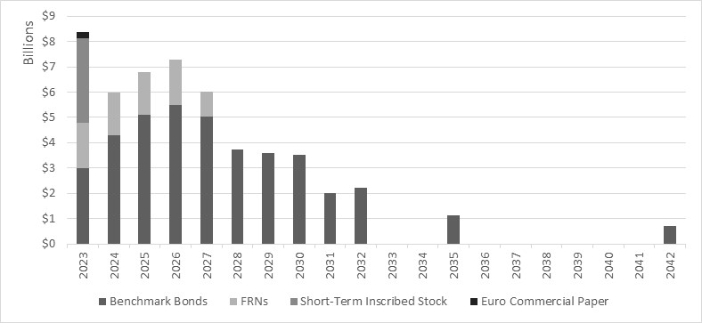

Reducing Risk Through Optimised Activity

At WATC, one of our corporate values is adaptability and we are constantly reviewing our performance, challenging our assumptions and exploring opportunities to improve our operations in order to deliver value. This approach has proved increasingly important amid ever-changing global economic and financial market environments.

Identification of Risk
Traditionally, the refinancing of maturing bond lines has been undertaken within a very narrow timeframe. However, in line with the historical ramp-up of the State’s borrowing requirements, the outstanding amount for each bond line increased significantly between 2009 and 2018. Consequently, larger amounts are required to be refinanced at maturity, which has increased our exposure to refinancing risk and potential financial market shocks.

Progressive Optimisation
During the financial year we conducted a pilot to determine the viability of an early buy- back program for outstanding debt issues within 12–18 months of maturity. In the pilot, near-term maturities were refinanced and extended into longer dated maturities, in line with and in support of State debt metric outcomes.

The success of the pilot scheme now provides us with an additional tool in the management and earlier refinancing of large debt maturities and will support the more efficient use of investment and credit limits.

We Supported…

The Shire of Wyndham-East Kimberley, supported with debt funding from WATC, built the Kununurra Splash Park for the community. The playground also acts as a popular tourism feature for the region.

Photo courtesy of Shire of Wyndham-East Kimberley

Successful Financial Management (continued)

Engaging with Investors
After a two-and-a-half-year hiatus due to COVID-19 induced restrictions, we
recommenced a travel program during the financial year to meet investors in person and promote the Western Australian economic and fiscal story.

In early June 2022, following the release of the 2022–23 Western Australian State Budget, the Western Australian Premier and Treasurer, Mark McGowan, along with Under Treasurer, Michael Barnes, and WATC CEO, Kaylene Gulich, presented to domestic investors and market intermediaries in Sydney. This trip also included meetings with members of our Fixed Interest Dealer Panel to discuss Western Australian budget outcomes, WATC’s 2022–23 borrowing program and financial market conditions.

We also partnered with a member of our Fixed Interest Dealer Panel in the latter half of June 2022 to deliver an offshore investor marketing program in Europe. Dovetailing into the Premier’s other overseas travel arrangements, there was a full itinerary of international investor meetings, which directly resulted in new investor participation in our bonds. The meetings also coincided with S&P Global Ratings’ announcement of the return of our State’s AAA credit rating, which further supported the positive Western Australian story we were sharing with investors.

AAA Credit Rating for
Western Australia

In June 2022, S&P Global Ratings reinstated Western Australia’s AAA credit rating due to “Western Australia’s continued budgetary outperformance compared with its domestic and global peers”.

S&P also stated the ratings upgrade was “supported by Western Australia’s track record of robust financial management, a very high-income economy, and exceptional liquidity”, and highlighted that these strengths “help counterbalance risks associated with dependence on the resources sector”.

Source: S&P Global Ratings, Research Update 27 June 2022

Prior to our national and international travel recommencing, we connected with our investors digitally by participating in virtual roundtables, teleconferences, webinars and online meetings. We also continued conversations with investors via Q&As and articles in KangaNews, an information service on the Australasian fixed-income markets with a substantial international readership.

Showcasing the State’s ESG Credentials

Important to Investors
The headline topic discussed at nearly all of our European investor meetings related to the State’s environmental, social and governance (ESG) credentials and ongoing commitment to the Paris agreement objective to achieve net zero greenhouse gas emissions by 2050.

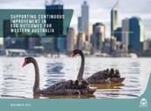
For the past 18 months WATC has coordinated a working group of 24 government agencies to consolidate information on the State’s current and planned ESG-related projects and initiatives. This work will help inform existing and prospective investors of the State's ESG profile, now and into the future, to aid their investment decisions in an increasingly ESG-conscious environment.

Framework Development
On 16 November 2021, the Premier launched the State Government’s inaugural ESG information pack titled Supporting Continuous Improvement in ESG Outcomes for Western Australia. The launch was followed up with a WATC-coordinated ESG update on 31 May 2022 following the release of the 2022–23 State Budget.
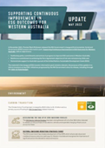
The most recent ESG update outlined our development of a sustainability bond framework to provide the Western Australian Government with a vehicle to finance initiatives meeting internationally recognised green and social bond standards. This framework will complement the State’s ongoing efforts to progress global objectives and the United Nations’ Sustainable Development Goals. Subject to final approvals and funding requirements, we will be in a position to issue the State’s first green or sustainable bond during 2023.

Western Australia Tackling Climate Change
Reinforcing the State’s commitment to the Paris agreement objective to achieve net zero greenhouse gas emissions for the whole State by 2050, in June 2022 the State Government announced a whole-of-government emissions reduction target for 2030 of 80 per cent below 2020 levels.

This interim target applies to emissions from all government agencies across the State, with a key contribution to come from the State’s commitment to invest an estimated $3.8 billion in renewable energy sources to replace all coal fired electricity generation by 2030.

Successful Financial Management (continued)

Our Plans for Successful Financial Management in 2022–23

Economic Outlook for 2022–23
While growth in the Australian economy remained strong through to the end of 2021–22, there is significant uncertainty over the outlook. Key drivers of uncertainty continue to be the evolution of the COVID-19 pandemic and government policy responses (particularly China’s Zero-COVID policy), the fallout from the war in Ukraine and ongoing central bank monetary tightening.

The introduction of aggressive central bank interest rate increases to combat higher inflation has raised the likelihood of a sharp slowdown in the global economy, with potential consequences for the stability of the financial system over the 2022–23 financial year.

Western Australian economic conditions are expected to remain robust in 2022–23, with growth driven by strong business and public sector investment, while export volumes are forecast to remain at record levels. However, the State is also vulnerable to developing global headwinds.

Sustainability Bond Framework
In 2023, WATC will implement a sustainability bond framework to provide a vehicle to finance initiatives that meet with internationally recognised green and social bond standards. This will meet growing investor demand and complement the Western Australian Government’s concerted efforts to improve ESG outcomes for the State.

Estimated Borrowing Program
for 2022–23
The new money program for 2022–23 is estimated at $1.5 billion. In addition, there is approximately $4.8 billion of maturing benchmark bonds and FRNs, resulting in a gross term funding program of $6.3 billion. The 2022–23 Western Australian State Budget also included an allocation of surplus funds to repay $1.2 billion of debt maturities, resulting in a net term funding program of $5.1 billion.

The sourcing of WATC’s funding is subject to various market conditions and market mix during the year and may be amended, as necessary, to meet WATC’s pricing, liquidity and lending targets.

The WATC forecast borrowing program across the forward estimates period is detailed in the following table:

Term Funding Requirement
 | 2022-23  $b | 2023-24-  $b | 2024-25  $b | 2025-26  $b
New Money Program (Estimated) | 1.5 | 0.7 | 0.6 | 0.4
Projected Maturities
Bond | 3.0 | 4.4 | 5.1 | 5.5
Floating Rate Note | 1.8 | 1.8 | 1.7 | 1.7
Total Maturities + New Money | 6.3 | 6.9 | 7.4 | 7.6
Debt Repayment | -1.2
Total Term Funding | 5.1 | 6.9 | 7.4 | 7.6

Funding Strategy for 2022–23
To meet the State’s funding and debt management requirements for 2022–23, we plan to:

- Pursue the opportunity to issue a new benchmark bond line, in thematic format under the Sustainability Bond Framework, with the aim of filling gaps in our bond maturity curve.

- Subject to refinancing and New Money requirements, issue a new five-year maturity FRN and continue to issue FRNs into outstanding lines, in response to investor demand and to accommodate the term floating-rate borrowing requirements of clients.

In addition, we will continue to:

- Issue across the yield curve to fund lending to clients.

- Enhance liquidity in existing lines of benchmark bonds by:

- maintaining sufficient volumes on issue to retain benchmark bond status;

- supporting these securities, where possible, in the market; and

- issuing through our Fixed Interest Dealer Panel by tender, private placement or syndication.

- Meet short-term lending and liquidity funding requirements by maintaining approximately $2.5 billion to $4.5 billion of short-term paper on issue through domestic Short-Term Inscribed Stock and the offshore Euro Commercial Paper Program.

- Ensure that debt issuance undertaken through domestic and offshore borrowing programs is issued in a manner that satisfies the requirements for an exemption from interest withholding tax under Section 128F of the Income Tax Assessment Act 1936.

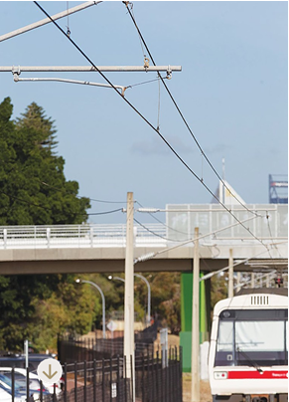

We Supported…

The Public Transport Authority oversees a comprehensive maintenance and renewal program of Perth’s passenger rail network, supported by debt funding and foreign exchange services from WATC. The program ensures the network’s continued safe and reliable operation as part of Western Australia’s public transport infrastructure.

Photo courtesy of Public Transport Authority of Western Australia

Optimising Our Performance

At WATC we are committed to continually improving our systems, capabilities, and processes to ensure we achieve our vision, deliver on our core objectives, and provide value to our clients and the State.

We strive to optimise our performance in accordance with the Western Australian Treasury Corporation Act 1986. Operating in a dynamic environment, we are continually faced with a range of risks and opportunities. We manage these risks and opportunities by working within our Board-approved risk management and compliance framework, which provides a clear governance structure for our operations.

Managing the State’s Liquidity

In managing the State’s financial assets and liabilities, we work closely with the Department of Treasury and our clients to ensure the State’s liquidity is effectively managed. Our Board has put in place two debt metric targets to further assist the ongoing management of our balance sheet and to contribute to improvements in the State’s liquidity.

16.5%

Debt Maturing Within 12 Months
Target: Less than 20%

219.5%

Liquid Asset Portfolio Cover
Target: Greater than 100%

As at 30 June 2022, both of these targets were successfully achieved while managing approximately $10.0 billion in investment funds for ourselves and our clients.

The achievement of these goals is an important part of the contribution we make to the State’s credit worthiness. In recognition of our work in this area, it was rewarding to note that a key component of S&P Global Ratings reinstating Western Australia’s AAA credit rating was due to the State’s “exceptional liquidity”.

Risk Management

What We Do
We operate in a dynamic financial market environment that presents both opportunities and risks that could materially impact our operations and our ability to meet our responsibilities to our clients, investors and the State. Our business is exposed to a wide range of risks associated with our operations, including market, credit, liquidity, funding, operational, reputational, and strategic risks.

We have a Board-approved risk management and compliance framework that, together with our corporate governance and organisational systems and processes, provides a sound structure for identifying, assessing, managing, monitoring and reporting material risks.

Our achievements for 2021–22 were all successfully managed and delivered within our Board’s approved framework and risk appetite.

Enhancing Our Risk Management
During the financial year we merged our Risk and Compliance teams into a newly restructured Risk Management branch, taking advantage of synergies within these teams.
The branch now coordinates the maturation and evolution of these important risk and compliance functions.

We also continued to evolve our approach to enterprise risk management, and strengthened our approach to how we identify, assess, communicate, manage and analyse risk across the organisation. Over 2021–22 this included:

- forming a new Operational Risk and Compliance Committee for enterprise-wide oversight of our non-financial risks;

- sharpening our Asset and Liability Committee’s mandate to better focus on managing financial risk; and

- reviewing, refreshing and renewing all of our key risk management policies.

Improving Our Operations

Value Improvement Program
Aligned with our culture of continuous improvement, we embedded a more formalised pathway by implementing our Value Improvement Program. This program has introduced business process improvement tools, techniques and strategies to review and improve both system and non-system processes.

Following on from the successful implementation of our new treasury management system in 2020, there were a number of process improvements that were identified and enabled by the new system. Our Value Improvement Program commenced with an initial pilot, which identified system and non-system-based opportunities for improvement. These ranged from providing extra training to deliver increased efficiencies and improvements in competencies, to ways of reducing rework and operational risks. The identified improvements have been prioritised and managed to completion. Following the pilot, the program will be expanded across the organisation during 2022–23.

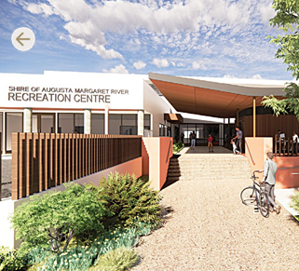
We Supported…

The Shire of Augusta Margaret River is refurbishing its recreation centre into a modern community facility for health and wellness, a project that is supported with debt funding from WATC.

Image courtesy of the Shire of Augusta Margaret River, designed by Gresley Abas

Optimising Our Performance (continued)

Change Advisory Board
During 2021–22, we introduced the Change Advisory Board (CAB) to provide a new approach to support system change management.

The CAB makes decisions on which systems changes to advance based on the highest value delivery in the shortest time. Through this mechanism, the CAB assists in the assessment, prioritisation, authorisation, resourcing and scheduling of complex system changes.

In the short time since its inception, the CAB has already significantly improved both the efficiency and effectiveness of system changes, and progressed initiatives across the organisation.

Digital Information Management
Our Digital Information Management project aims to develop a high-level strategy and prioritised roadmap to further improve the way we manage our information. The goal is to move towards a seamless way of working by:

- ensuring all our information is consistently structured, enabling easy user access and collaboration;

- reducing the risk of the loss of information; and

- managing our information security and compliance within the requirements of the State Records Office of Western Australia.

Phase 1 of the project is to review and document our information sources, systems and assets. Building on the findings of Phase 1, Phase 2 will establish the information management architecture and associated governance framework to support a frictionless way of working.

Efficiency and Cost Effectiveness

We use our Administration Cost Ratio Key Performance Indicator to ensure we are delivering high- quality products and services while still being a cost-effective solution for our clients. This ratio allows us to monitor our administrative efficiency and the cost effectiveness of funding client borrowing. It measures the average administrative on-cost that must be borne by our clients.

In 2021–22 we achieved an Administration Cost Ratio of 0.039 per cent, well below our target of less than 0.05 per cent, affirming that we continue to be cost effective while delivering value to clients and the State.

See Key Performance Indicators on page 100 for more details.

Information and Communications Technology

Staying Vigilant on Cyber Security
Information and communications technology is critical to our continued operations and ongoing success. With the ever-increasing risk of cyber threats and attacks, we escalated our focus on cyber security.

During the financial year we made significant enhancements to our cyber security posture and maturity as part of an ongoing program of continuous improvement. This program ensures the integrity and safekeeping of our information, systems and assets, and uninterrupted continuation of our operations.

Improving Remote Working Capabilities
COVID-19 related disruptions necessitated flexible working arrangements for all staff. We provided our staff with critical support by facilitating remote working capabilities and ensuring a secure and seamless transition between office and home.

Throughout the year we continued to evolve and enhance our remote working facilities as staff worked from home more often. This included the rollout of an improved virtual private network. We also proactively provided staff with guides and recommendations on how to maintain and improve the security of their home information and communications technology set-up.

Our Plans to Optimise Performance in 2022–23

As part of the implementation of our new Digital Strategic Plan, we will be focussing on:

- further maturing our cyber security capabilities;

- optimising our information systems;

- improving our change management to deliver seamless information management; and

- training and developing staff in the use of new technologies and cyber security awareness.

We will also continue to evolve our approach to risk management and expand our Value Improvement Program across our organisation.

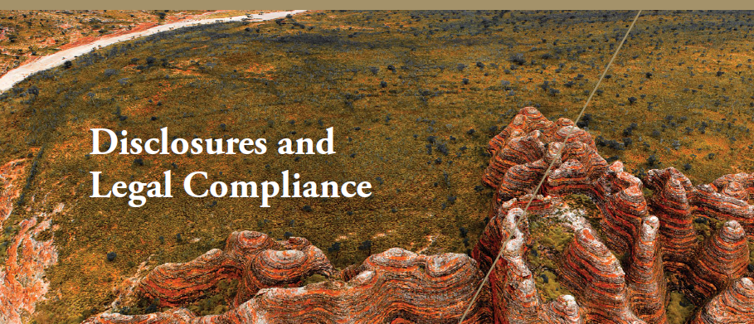

Managing Our Information Assets

Information is critical in supporting our business activities and is managed in accordance with the State’s records management requirements.

Information Management

Data, information and records are all managed as valuable assets that are critical to the success of our operations. All information assets are captured and managed according to our business needs, ensuring the relevant information is readily accessible and appropriately secured if sensitive.

We have an approved recordkeeping plan in accordance with Section 19 of the State Records Act 2000 (State Records Act), which meets the requirements of Standard 2, Principle 6. We manage our records under Recordkeeping Plan (RKP) 20200032, which was approved by the State Records Office of Western Australia on 26 March 2021 and is valid until March 2026.

Our information management policies and procedures are regularly reviewed and updated

as required, as part of our ongoing information governance processes.

COVID-19 and Information
Management
The pandemic has changed how we operate and put a greater emphasis on workplace flexibility and remote working. This has led to dynamic, ongoing changes to how information is captured and managed.

As part of a pilot project, we are implementing new tools to enhance the functionality
of information and provide greater user flexibility. This project allows us to capture more information whilst still meeting our recordkeeping responsibilities and compliance requirements.

Information Management Roadmap

Information Management Strategy
Last year we developed a high-level strategy and prioritised roadmap to facilitate improvements in how we manage information as we shift towards a modern digital workplace and workforce. Aligned with the requirements of the State Records Office of Western Australia, the roadmap guides our development of a more contemporary and compliant digital information management landscape that improves the usability and accessibility of all our information.

Information Assets Register
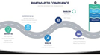
One of the first milestones on our roadmap journey was achieved during 2021–22 when we developed a comprehensive register of all our information assets. Staff involvement has been fundamental to this wide-ranging review of our business processes and the information assets generated.

An additional benefit is that staff now also have higher visibility and ownership of their own information assets and are more aware of compliance and security considerations.

Recordkeeping Training

Our recordkeeping induction program
for new staff continued. All 13 of our new staff completed the program within two weeks of their start date, in line with our policy requirements.

During the year we redesigned our recordkeeping induction program to enable online delivery, providing greater flexibility to accommodate remote working. Our new program is a combination of:

- An initial introduction and overview of our records and information framework, including where and how to find information.

- An audio guided online learning module introducing our information management policy and outlining employee responsibilities and requirements. Once the module is completed, a quiz is used to embed understanding.

- A facilitated practical workshop on how to use our electronic document records management system. After completing the workshop, our Information Management Officer meets with new staff to see how they are finding using the system, answer any of their questions and obtain feedback on their induction.

In accordance with our policy, all staff are required to undertake records awareness refresher training every two years. During the year we identified specific staff needs in this area and updated our refresher training program accordingly.

Managing Our Information Assets (continued)

Our 2021 Annual Report
Wins Award

We were delighted when our 2021 Annual Report won a silver award in the Government Trading Enterprises category at the 37th Annual W.S. Lonnie Awards.

The Lonnie Awards are presented by the Institute of Public Administration Australia WA. Designed to highlight the importance of annual reports being accountable and transparent, the awards recognise excellence in annual reporting across the Western Australian public sector.

Freedom of Information

The Freedom of Information Act 1992 (FOI Act) enables the public to apply for access to documents held by WATC. Guidance on how to apply and obtain requested documents is set out in our Information Statement, which

is available via our website. The statement is prepared in accordance with the requirements of the FOI Act and is regularly reviewed
and updated.

We received two FOI applications and one third-party consultation during the financial year. These were all processed in accordance with the FOI Act and our FOI Policy, and within the required timeframes.

Complaints

We are committed to providing an accessible, fair and efficient complaints management process. Our Complaints Management
Policy is informed by guidance issued by the Ombudsman Western Australia. This includes the appointment of a dedicated Complaints Officer who is responsible for impartially assessing complaints and notifying our Chief Executive Officer about all complaints received and their progress towards a resolution. The policy stipulates strict timeframes for responding to and resolving complaints. We regularly review our complaints policy to ensure it remains current and is an easy process for users. There are multiple ways to lodge a complaint, including an online form on our website, by mail, by email or in person.

Complaints, though rare, are viewed as an opportunity to improve our business operations and staff development. We received no complaints in the 2021–22 financial year.

Our Plans for Managing Information in 2022–23

As part of our Digital Information Strategy, we will continue to progress the design, implementation and user adoption of our new Microsoft 365 information architecture, together with improving our internal communications and recordkeeping.

We will continue to monitor, review and update our information management policies and procedures as required.

Our People

Essential to the continued success of our organisation is having an engaged and capable workforce that is aligned to our values and invested in delivering our strategic and operational goals, both now and into the future.

Our Team

Acknowledged by clients and stakeholders, our workforce is both capable and experienced, and possesses high levels of professionalism, expertise and technical ability. To maintain and enhance these capabilities, we support all our staff with learning and professional development opportunities – covering both technical and interpersonal skills.

90 Years of Contribution

During 2021–22, we had a number of our long-serving team members retire. With a combined tenure of over 90 years, the collective knowledge and experience of these former colleagues is immense.
We would like to express our appreciation and acknowledge the significant contributions made to both WATC and the State by:

- Robert Beckett, Head of Information and Communications Technology

- Rex Sleeman, Technical Specialist

- Guy Sojan, Treasury Operations Manager and Registrar

We wish them all well in retirement and thank them for their contributions and the positive legacy they leave behind.

During the financial year, we increased our staff numbers from 79 to 81. Staff turnover for 2021–22 was higher than in previous years, which was due to a number of people retiring and the current dynamics of the employment market. However, when measured against industry standards, our staff turnover remains relatively low at 12.4 per cent at 30 June 2022.

Staff Profile | 2021–22 | 2020–21
Number of Staff at  30 June | 81 | 79
Full-Time Permanent | 69 | 68
Full-Time Temporary | 2 | 2
Part-Time Measured on a Full-Time Equivalent (FTE) Basis | 6.46 | 5.74
On Secondment | 0 | 2

Our People (continued)

Improving Staff Engagement

We strive to create an environment where all staff are encouraged and supported to do their jobs to the very best of their abilities. We have a key performance indicator that measures staff engagement through a confidential annual staff survey.

During 2021–22 our staff engagement rating was 70 per cent, a significant increase on previous years’ results. The improvement in the rating reflects positively on our continued focus, initiatives and strategies to improve staff engagement.

See Key Performance Indicators on page 10 for more details.

Resilience and Adaptability

Our people continued to show resilience and adaptability in dealing with COVID-19
disruptions. As dictated by the evolving nature of the pandemic and associated public health response, and supported by technology, staff were able to successfully transition between working from home and office as required. Not only did this ensure the safety and wellbeing of our staff, but also that our operations could continue with minimal disruption.

Our Executive and Human Resources teams effectively managed the changing situation by:

- actively monitoring and responding to public health advice and public sector policy on COVID-19; and

- keeping all staff informed of the latest requirements.

As aligned with public sector requirements, a COVID-19 vaccination policy was introduced and later removed when it was no longer mandated.

During this time, we also placed a greater focus on promoting staff wellbeing and positive mental health. We supported and helped staff

deal with the changes and challenges by sharing relevant tips and useful information, and regularly touching base with individuals to ensure everyone stayed connected.

Flexible Working Arrangements

We are committed to developing and supporting a culture that promotes a flexible and healthy work–life balance for our people. A positive outcome from COVID-19 related disruptions was that we implemented a revised policy expanding our flexible working arrangements.

The revised policy enables our people to better balance the challenges of work and personal circumstances while maintaining effective performance and enhancing productivity.
The revised flexible working policy allows staff to work from home for up to two days per week, or on an ‘as required’ basis, in agreement with their manager. Since the new policy was implemented, close to half of our people have established regular working from home arrangements.

Inclusivity Journey

In providing a productive and positive work environment, our staff Code of Conduct requires that all people working at WATC act professionally, courteously and honestly,
treating others with respect as reflected in our corporate values.

As an extension of our Code of Conduct, we are formalising a diversity and inclusion plan that builds on our current positive practices and will guide our progress to be a more

inclusive organisation. As part of this plan, we started our journey to better understand our role in reconciliation.

During 2021–22 we celebrated National Reconciliation Week, an event that encourages people to learn more about First Nations’ cultures and our shared history of Australia. In recognition of the event, we provided staff with relevant information and resources to improve awareness and understanding, along with details of how they could get involved.

Supporting Women in Capital Markets
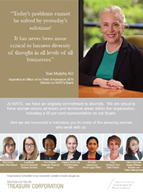
We were pleased to continue our association with the KangaNews Women in Capital Markets Yearbook, which acknowledges the importance of gender diversity in capital markets and discusses its contribution to leadership and innovation.

The yearbook also includes submissions from financial market participants, outlining initiatives to promote gender diversity and how these feed- through to a more inclusive industry.

As a supporting sponsor of the yearbook, we were invited to promote our initiatives and profile some of the amazing women in our organisation, sharing some inspiration from our Director, Susan Murphy:

“Today’s problems cannot be solved by yesterday’s solutions! It has never been more critical to harness diversity of thought in all levels of all businesses.”

Our People (continued)

Participation in Treasury Graduate Program

WATC participates in the Department of Treasury’s Graduate Program. This is a structured initiative that aims to provide newly employed graduates with a range of training and development opportunities while exposing them to a variety of work and projects across government.

As part of the program, we offer a six-month rotation placement to high-achieving graduates with an interest in our role within government and the financial markets we operate in. During 2021–22 we hosted one graduate who worked on a range of projects while spending time with our Risk and Advisory Services teams. During their rotation with us, and in addition to contributing to projects that supported our clients and the State, we assisted the graduate to develop their skills in modelling, financial analysis, reporting and presenting financial information.

New Safety Legislation

We are committed to providing a safe and healthy working environment that promotes staff wellbeing and complies with the relevant legislation. With the new Work Health and Safety Act 2020 and regulations that came into effect on 31 March 2022, we worked through the changes and reviewed and updated our policies, procedures and oversight to ensure alignment with the new legislation. This included revising the charter of our Work Health and Safety Committee.

We took the opportunity to provide an outline of the new legislation’s key features to all staff. We explained how the legislative changes relate to our workplace and reminded everyone of their responsibilities and obligations.

Annual Performance on Work Health and Safety Management

Through a culture of continuous improvement in workplace health, safety and wellbeing, we aim to achieve and maintain a zero lost-time-injury rate, and actively encourage and facilitate staff wellbeing.

We held four Work Health and Safety (WHS) committee meetings during 2021–22. These were attended by both our staff health and safety representatives and members of management. Regular monthly workplace inspections were performed, with identified issues reported and managed. We complied with all legislation relating to WHS, workers’ compensation and injury management.

In accordance with the reporting requirements of Treasurer’s Instruction 903 (13), there were no lost time injuries, as outlined in the following table. No workers’ compensation claims were made.

Measures | Actual Results |  |  | Targets | Comments  on Result
 | 2019–20¹  (Base year) | 2020-21  (Prior Year) | 2021–22  (Current Year)
Number of Fatalities | 0 | 0 | 0 | 0 | Achieved
Lost Time Injury and/or Disease (LTI/D) Incidence Rate | 0 | 0 | 0 | 0 | Achieved
Lost Time Injury and/or Disease (LTI/D) Severity Rate | 0 | 0 | 0 | 0 | Achieved
Percentage of Injured Workers Returning to Work Within 13 Weeks | n/a | n/a | n/a | ≥80% | n/a
Percentage of Injured Workers Returning to Work Within 26 Weeks | n/a | n/a | n/a | ≥80% | n/a
Percentage of Managers and Supervisors Trained in Occupational Safety, Health and Injury Management Responsibilities | 91% | 91% | 100% | ≥80% | Achieved
1 The performance reporting examines a three-year trend and, as such, the comparison base year is to be two years prior to the current reporting year.
n/a: not applicable

Our Plans for Our Workplace and People in 2022–23

We will review and improve how we articulate our staff benefits and our value proposition to assist with effective recruitment and staff engagement.

We will develop and implement our Diversity and Inclusion Plan. This plan will include reconciliation actions, which will build on our current positive practices and guide our progress towards becoming more inclusive.

We will implement individual development plans for all our people to assist with identifying opportunities and managing each person’s ongoing professional development and training.

Board of Directors, Governance

Our Board of Directors is responsible for the performance of WATC’s functions under the Western Australian Treasury Corporation Act 1986.

In order to ensure that WATC carries out its functions in the best interests of the State, our clients and other stakeholders, the Board of Directors (the Board) of WATC sets the strategic direction of WATC, with the agreement of the Premier, and establishes the policies and principles under which we operate.

The corporate governance processes established by the Board ensure that they are able to fulfil WATC’s statutory obligations, guide the affairs of WATC and oversee our
performance. The Board relies on and holds to account the Chief Executive Officer for the operational management of WATC and implementation of the strategic direction.

Board Composition

The membership of the Board is determined in accordance with Section 5B of the Western Australian Treasury Corporation Act 1986 (the Act). The directors of WATC at 30 June 2022 are as follows:

Name | Position | First Appointed | Term Expires
Michael Barnes | Chairperson | Statutory | Statutory
Michael Court | Deputy Chairperson | 1/07/2017 | n/a
Kaylene Gulich¹ | Chief Executive Officer | Statutory | Statutory
David Brumby | Director | 17/02/2020 | 31/12/2022
Philippa Hobson | Director | 17/02/2020 | 31/12/2022
Susan Murphy | Director | 01/01/2019 | 31/12/2024
¹ The Chief Executive Officer is the only director with executive responsibilities.
n/a: not applicable
The Secretary to the Board is Steven Luff, Chief Financial Officer.

Board Remuneration

The annual remuneration for WATC’s Board is as follows:

Name | Type of Remuneration | Period of Membership | 2021–22  $
M Barnes | Not eligible | 12 months | 0
M Court | Not eligible | 12 months | 0
K Gulich | Not eligible | 12 months | 0
D Brumby | Annual | 12 months | 42,789
P Hobson | Annual | 12 months | 53,753
S Murphy | Annual | 12 months | 42,789

Board Responsibilities

The Board is responsible for the performance of the functions of WATC under the Act. These functions include:

- to borrow moneys and lend moneys to the Western Australian public sector;

- to develop and implement borrowing programs for the purposes of the Act;

- to manage the financial rights and obligations of WATC;

- to advise on financial matters, including debt management, asset management, and project and structured financing;

- to manage investments for the Department of Treasury and other government authorities; and

- to assist government authorities with managing their financial exposures.

In fulfilling this role, the Board guides and monitors the affairs of WATC. This includes:

- reviewing and establishing, with the Premier's agreement, WATC’s Strategic Development Plan and Statement of Corporate Intent each year;

- monitoring the performance of WATC; and

- ensuring that appropriate accounting, risk management, budgeting, compliance, information technology, and internal control policies, systems and reporting processes are in place – these include WATC’s Risk Management Policy and Business Continuity Plan.

Constitution and Proceedings of the Board

The Constitution and proceedings of the Board are provided for in Schedule 2 of the Act.

Statutory Corporations (Liability of Directors) Act 1996

WATC’s directors are bound by the provisions of the Statutory Corporations (Liability of Directors) Act 1996. Accordingly, directors are required to comply with the same fiduciary responsibilities and duties of loyalty and good faith owed by directors of companies incorporated under the Corporations Act 2001. In accordance with Clause 18 of Schedule 2 of the Western Australian Treasury Corporation Act 1986, directors are required to leave the room and not take part in deliberations of matters in which they have some material personal interest.

We Enabled…

The Shire of Exmouth acquired and constructed additional housing for accommodating essential employees, enabled through debt funding from WATC.

Photo courtesy of Shire of Exmouth

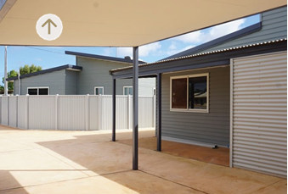

Board Committees

To assist in the execution of their responsibilities, the Board has established an Audit Committee and a People and Remuneration Committee.

Attendance at Meetings by Directors

Details of attendance at the Board and Board Committee meetings by each director during the year are as follows:

Director | Board |  | Audit  Committee |  | People and  Remuneration  Committee
 | Held | Attended | Held | Attended | Held | Attended
M Barnes | 6 | 4 |  |  | 4 | 3
M Court | 6 | 6 | 4 | 4 | 4 | 4
K Gulich¹ | 6 | 6 | 4 | 3 | 4 | 4
D Brumby | 6 | 5 |  |  | 4 | 3
P Hobson | 6 | 5 | 4 | 4 | 4 | 4
S Murphy | 6 | 5 | 4 | 4 | 4 | 4
¹ K Gulich was invited to attend Audit Committee meetings.

Audit Committee

The role of the Audit Committee is to give the Board additional assurance regarding the quality, integrity, reliability and adequacy of our accounting and internal control systems,
financial reporting and compliance processes. At meetings of the Audit Committee, the external and internal auditors are invited
to address the Audit Committee without management present.

The members of the Audit Committee at 30 June 2022 were Philippa Hobson
(Chairperson), Michael Court and Susan Murphy. Members are non-executive directors. The Secretary to the Committee was Phillip Metaxas, Senior Compliance Officer.

People and Remuneration Committee

The People and Remuneration Committee reviews and makes recommendations to the Board on remuneration packages and policies applicable to the employment terms and conditions for all of our people, including the Chief Executive Officer.

The members of the People and Remuneration Committee at 30 June 2022 were Michael Barnes (Chairperson), Michael Court, Kaylene Gulich, Philippa Hobson, Susan Murphy and David Brumby. The Secretary to the Committee was Rebecca Ridgway, Human Resources Manager.

Legislation

Legislation Administered

Western Australian Treasury Corporation Act 1986

Legislation Impacting on WATC’s Activities

State Legislation Impacting on Activities

- Auditor General Act 2006
- Corruption, Crime and Misconduct Act 2003
- Disability Services Act 1993
- Electoral Act 1907
- Electronic Transactions Act 2011
- Equal Opportunity Act 1984
- Fair Trading Act 2010
- Financial Management Act 2006
- Freedom of Information Act 1992
- Long Service Leave Act 1958
- Pay-roll Tax Assessment Act 2002
- Procurement Act 2020
- Public and Bank Holidays Act 1972
- Public Interest Disclosure Act 2003
- Public Sector Management Act 1994
- Salaries and Allowances Act 1975
- Stamp Act 1921
- State Records Act 2000
- State Superannuation Act 2000
- Statutory Corporations (Liability of Directors) Act 1996
- Work Health and Safety Act 2020
- Workers’ Compensation and Injury Management Act 1981

Commonwealth Legislation Impacting on Activities

- A New Tax System (Goods and Services Tax) Act 1999
- Anti-Money Laundering and Counter-Terrorism Financing Act 2006
- Census and Statistics Act 1905
- Copyright Act 1968
- Disability Discrimination Act 1992
- Fair Work Act 2009
- Fringe Benefits Tax Act 1986
- Income Tax Assessment Act 1936
- Superannuation Guarantee (Administration) Act 1992
- Taxation Administration Act 1953

Corporate Governance

External and internal oversight of WATC outcomes and conduct ensures adherence to our core value of integrity.

Ethical Standards and Codes of Conduct

The Board acknowledges the need for, and the continued maintenance of, the highest standards of corporate governance practices and ethical conduct by WATC’s directors and staff and has established codes of conduct for directors and staff respectively.

The staff Code of Conduct (the Code) reflects and supports WATC’s values and provides our people with a clear, concise and relevant guide to standards of behaviour in the workplace. The Code also applies to directors unless there is an inconsistency, in which case the Directors’ Code of Conduct will apply.

WATC has also adopted the Western Australian Public Sector Code of Ethics and endorsed, in principle, the code of conduct developed by the Australian Financial Markets Association.

Compliance

The role of WATC’s compliance function is to ensure that WATC maintains its high prudential standards and has the appropriate procedures in place to comply with the Western Australian Treasury Corporation Act 1986 and other relevant legislation, our policies and industry standards.

Auditors

External Audit
Section 21 of the Western Australian Treasury Corporation Act 1986 states:

“The provisions of the Financial Management Act 2006 and the Auditor General Act 2006 regulating the financial administration, audit and reporting of statutory authorities apply to and in respect of the Corporation and its operations.”
In accordance with the provisions of the Financial Management Act 2006 and the Auditor General Act 2006, WATC’s external auditor is the Auditor General for Western Australia. The Auditor General utilises the services of Ernst & Young to conduct the annual audit.

Internal Audit
WATC’s internal audit function is outsourced to PricewaterhouseCoopers. Appointment to this role by WATC is subject to the Common Use Arrangements authorised by the Department of Finance for accessing audit services and financial advice.

Quarterly Report to the Premier

With the exception of the June quarter, WATC submits a quarterly report on our operations to the Premier. This report is tabled in Parliament by the Premier.

Professional Advice

Directors are entitled, with the prior approval of the Chief Executive Officer, to obtain such resources and information from WATC, including direct access to management and professional advisers, as they may require in order to carry out their duties as directors. Directors are also entitled, with the prior approval of the Chairperson, to seek independent professional advice, at the expense of WATC, to assist them to carry out their duties as directors.

Pricing Policy

WATC operates in a dynamic market where the price of our lending to the public sector is primarily driven by the cost of our borrowings. This cost fluctuates according to the prevailing level of interest rates. WATC sets our lending rates at a competitive level after taking into account the cost of funds, market risk, administration costs and the return on capital. The pricing for financial advice and funds management is determined on a cost- recovery basis.

Insurance Policy

An insurance policy has been taken out to indemnify members of the Board against liabilities under Sections 13 and 14 of the Statutory Corporations (Liability of Directors) Act 1996. The amount of the insurance premium paid for 2021–22 was $112,118.

Expenditure on Advertising

Under Section 175ZE of the Electoral Act 1907, WATC is required to disclose any expenditure we make to:

- advertising agencies

- market research organisations polling organisations

- direct mail organisations

- media advertising organisations.

For the year ended 30 June 2022, the only disclosable expenditure incurred was in relation to advertising, where the following amounts were paid:

- $37,840 paid to BondNews Ltd, trading as KangaNews

- $3,923 paid to Beilby Downing Teal Pty Ltd

- $512 paid to Seek Ltd.

Unauthorised Use of Credit Cards

Our staff hold corporate credit cards where their role warrants usage. There were no instances of personal expenditure on a corporate card.

Registry and Treasury Operations

Link Market Services Ltd (trading as Link) acts as agent for providing registry services on behalf of WATC. WATC uses the systems and services detailed in the table below to facilitate confirmation and settlement of financial transactions.

Provider | System | Purpose
Austraclear Ltd | Austraclear | Australian dollar cash, short-term money market, fixed interest and foreign exchange transactions
Bank of America | CashPro Online | Foreign currency transactions
Clearstream | CreationOnline | Repurchase of offshore issues
Citibank NA | CitiDirect for Securities | Issuance of Euro Commercial Paper and Euro Medium Term Notes
Commonwealth Bank of Australia | Commbiz | Foreign currency and Australian dollar transactions

Contact Details

Western Australian Treasury Corporation

Head Office Level 12, St Georges Square
225 St Georges Terrace
PERTH WA 6000

Postal Address PO Box 7282
PERTH CLOISTERS SQUARE WA 6850

Telephone (+61) 8 9235 9100
Email watc@watc.wa.gov.au
Website www.watc.wa.gov.au

Registry Information

Link Market Services Limited is the agent for supplying registry services to Western Australian Treasury Corporation’s stockholders. Please call Link Market Services Limited on Freecall
1800 098 828 for all stockholding enquiries.

Link Market Services Limited office addresses:

Western Australia Level 12, QV1 Building
250 St Georges Terrace
PERTH WA 6000

Victoria Level 13, Tower 4
727 Collins Street
MELBOURNE VIC 3008

New South Wales Level 12
680 George Street
SYDNEY NSW 2000

Queensland Level 21
10 Eagle Street
BRISBANE QLD 4000

