<pp>1

Annual Report 2023

Western Australian Treasury Corporation
Financial Solutions for the Benefit of All Western Australians

Image Caption:
Aerial photo of Elizabeth Quay, Perth. Image courtesy of Tourism Western Australia.

<pp>2

Acknowledgement of Country
We acknowledge the Traditional Custodians throughout Western Australia and their continuing connection to land, waters and community. We pay our respects to all Aboriginal peoples and their cultures, and to elders both past and present.

About this Report
This annual report provides information about the services and performance of Western Australian Treasury Corporation and includes audited financial statements and performance indicators for the financial year ending 30 June 2023. A full copy of this annual report, along with previous years’ annual reports, is available in PDF and other formats on our website at watc.wa.gov.au.
Hard copies are printed on paper that contains 100% recycled fibre and is FSC® Mix Certified, which ensures that pulp is derived from well-managed forests and recycled wood or fibre. Manufactured by an ISO 14001 certified mill.

Image Caption:
Aerial photo of the Z Bend Lookout, Kalbarri National Park. Image courtesy of Tourism Western Australia.

<pp>3

Contents

Overview
Statement of Compliance
Vision, Objectives and Values
Financial Year Snapshot
Key Achievements
Chairperson and CEO’s Report
Performance Against Targets
About WATC
Board of Directors

Agency Performance
Providing Value to Clients
Successful Financial Management
Optimising Our Performance

Disclosures and Legal Compliance
Managing Our Information Assets
Our People
Board of Directors’ Governance
Board Committees
Legislation
Corporate Governance

Financial Statements
Removed from this version

Contact Details
Western Australian Treasury Corporation
Registry Information

<pp>4

Overview
- Statement of Compliance
- Vision, Objectives and Values
- Financial Year Snapshot
- Key Achievements
- Chairperson and CEO’s Report
- Performance Against Targets
- About WATC
- Board of Directors

Image Caption:
Representation of the New Library, Administration and Community Centre.
Image courtesy of Shire of Dardanup.
Shire of Dardanup
New Library, Administration and Community Centre
Supported with debt funding from WATC, the Shire of Dardanup is building a new library, administration and community centre. The landmark building, which utilises sustainable timber construction, will be a community hub for collaboration, connection and innovation.

<pp>5

Statement of Compliance

To the Honourable Rita Saffioti BBus MLA
Deputy Premier; Treasurer; Minister for Transport; Tourism

In accordance with Section 63 of the Financial Management Act 2006, we hereby submit for your information and presentation to Parliament, the Annual Report of the Western Australian Treasury Corporation for the financial year ending 30 June 2023.
The Annual Report has been prepared in accordance with the provisions of the Financial Management Act 2006.
Yours sincerely,

M BARNES PSM, FIPAAWA
CHAIRPERSON
Western Australian Treasury Corporation
25 August 2023

K GULICH PSM
CHIEF EXECUTIVE OFFICER
Western Australian Treasury Corporation
25 August 2023

<pp>6

Vision, Objectives and Values
Western Australian Treasury Corporation (WATC) is the State’s central financial services provider, working with our public sector clients to achieve sound financial outcomes.

Vision
To be recognised as the best at providing financial solutions for the benefit of the Western Australian public sector.

Objectives
Our strategic focus for 2022–23 centred on the following key strategic objectives:
- Providing high-quality, cost-effective products and services to the Western Australian public sector.
- Maintaining ready access to domestic and international capital markets to ensure funds are raised to finance client borrowing needs.
- Optimising the performance of WATC in accordance with the Western Australian Treasury Corporation Act 1986 and the risk appetite of WATC’s Board.

Values
We transact all business in accordance with our corporate values of:
- Integrity - Being open, honest and accountable and adhering to the highest professional and ethical standards. Honouring our promises.
- Partnership - Working collaboratively with our clients and colleagues towards achieving successful outcomes.
- Adaptability - Challenging ourselves to think creatively and to continuously improve.
- Achievement - Focusing on delivering valued outcomes for Western Australia.
- Leadership - Using our knowledge and experience to contribute to the long-term benefit of Western Australia.

<pp>7

Financial Year Snapshot

$49.8b Total Debt
Delivering on our ongoing responsibility to raise funds on behalf of the State of Western Australia, WATC’s total debt on issue amounted to $49.8 billion at 30 June 2023.
More on page 32

$44.9b Client Debt
We managed a total of $44.9 billion of client debt on behalf of government agencies, local governments and public universities as at 30 June 2023.
More on page 23

$550m Foreign Exchange
During the 2022–23 financial year, we transacted over $550 million in 10 currencies on behalf of 18 clients and assisted in effectively managing their foreign exchange risk.
More on page 28

50 Advisory Engagements
Supporting clients and the State with independent expert financial advice, we completed 50 client engagements during the 2022–23 financial year.
More on page 25

<pp>8

Key Achievements

Sustainability Milestones
Release of Sustainability Bond Framework and Green Bond
Following the release of the Sustainability Bond Framework in May, WATC successfully issued its first green bond. This raised $1.9 billion, generating over $6 billion in bids from more than 60 domestic and international investors.
More on pages 34 & 35

Lending Reform
Delivery of Financially Sustainable Local Government Lending Solution
We collaborated with our local government clients to effectively incorporate changes to our lending policy for local governments, ultimately providing more financially sustainable, long-term lending solutions for the local government sector.
More on page 24

Building Knowledge
Ongoing Client Education and Development
We continued to develop client knowledge and understanding through a varied educational program that included economic presentations, foreign exchange seminars and industry forums.
More on page 30

<pp>9

Positive Feedback
High Levels of Client Satisfaction Reported Across Client Surveys
Clients expressed 100% satisfaction in relation to WATC’s high-quality, cost-effective solutions after responding to an independent survey and providing direct feedback.
More on page 29

Advisory Recognition
Appointment to Infrastructure WA Panel
WATC’s Advisory Services was selected from a pool of financial and engineering consultants from around Australia to join the Infrastructure WA Panel, recognising the broad skills and collective experience of the team.
More on page 26

People Programs
Programs and Initiatives to Enhance Working at WATC
To support and develop work culture at WATC, our HR team enhanced its approach to reward and recognition, implemented a calendar of wellbeing initiatives and delivered a Diversity and Inclusion program with a series of events.
More on pages 44 & 45

<pp>10

Chairperson and CEO’s Report

Despite ongoing volatility, some semblance of normality returned to global financial markets in 2022–23. Legacies from the COVID-19 pandemic and other events endured, however, as economies, communities and governments adapted to a higher inflation, lower growth environment.
While Western Australia was in a unique position to repay State debt during the year, it was not immune to unpredictable global economic and market conditions. Despite the challenges, at WATC we continued to work diligently to deliver high-quality, cost-effective services to support our clients while successfully managing financial risks in a changing landscape.
In Europe, the destabilisation caused by Russia’s invasion of Ukraine continued to be felt during an increasingly protracted conflict, with fuel and food security taking centre stage. Globally, central banks continued to battle the highest inflation in a generation, caused by COVID-era support measures, supply-side constraints, and the war in Ukraine.
An unusually intense period of volatility was experienced during March and April 2023 following the collapse of two mid-sized US banks, due to a mix of loose regulation, poor management and the impacts of rapidly rising interest rates. The subsequent demise of Swiss banking giant Credit Suisse triggered fears of wider contagion in the banking system. Concerns eased as regulators quickly stepped in to guarantee deposits at the US banks in question and provide liquidity support for solvent institutions, and when Credit Suisse was bought by UBS.
While interest rate increases were almost universally applied across the major economies (Japan and China being the exceptions), inflation was initially slow to respond. Aided by a slowdown in the global economy, inflation started to ease in 2023 but remains well above central bank targets, leaving commentators guessing on the likelihood of a hard or soft landing. In Australia, the tightening cycle saw the Reserve Bank of Australia (RBA) raise its cash rate target from 0.85% in June 2022 to 4.10% a year later. While inflation has recently eased, and markets have largely unwound their pricing for further increases, the RBA has warned that additional tightening could be required. Commentators remain mixed on interest rate expectations for 2023–24.
Amid this global activity, Western Australia continues to be uniquely placed among the Australian States to manage and withstand a range of economic challenges. Supported by sustained economic growth, balance sheet repair and strong revenues, the State responded positively to the challenging economic conditions in 2022–23. The State Government delivered its sixth- consecutive budget surplus, with further surpluses forecast for coming years. Unemployment remained at historically low levels while participation rates were high. Overall, Australia’s economic growth is predicted to slow into the new year as higher interest rates impact activity, but the downturn is expected to be less pronounced in Western Australia due to the strong demand for (and pricing of) our commodities.

<pp>11

While not strictly occurring during 2022–23, in early July 2023 Moody’s Investors Service revised Western Australia’s and WATC’s credit rating to Aaa with a ‘stable’ outlook, reflecting Western Australia’s strong financial management. This followed a similar upgrade by S&P Global Ratings in June 2022. As a result, Western Australia is now the only State or Territory with a triple-A credit rating from both major international ratings agencies. Globally, we are one of a very small number of jurisdictions with such a rating.
Interest rate changes impacted government bond yields, with WATC’s 10-year yield ranging from 3.49% to 4.88% over the year. We issued $4.2 billion in benchmark bonds and floating rate notes over the financial year to refinance our existing maturities as the State moved to fund its asset investments with cash surpluses and repay existing debt. By the end of 2022–23, we managed $49.8 billion of debt, with the ongoing management of our key balance sheet metrics seeing debt maturing within 12 months at 16%, reflecting strong liquidity in the public sector, and our liquid asset portfolio cover at 234%. Both figures were comfortably within our Board’s targets of less than 20% and above 100%, respectively.
A highlight for the year was the launch of our Sustainability Bond Framework (Framework) and inaugural green bond. Both releases were the culmination of years of work for WATC and our agency partners, and showcased the breadth and depth of positive activities undertaken across the State. Over recent years, we have increasingly demonstrated the alignment between the Western Australian Government, industry and the wider community, and the collective commitment to continuously improve on environmental and social outcomes. We would like to thank all of our government and banking partners for supporting this work. We would also like to acknowledge the wide range of investors we met with over the roadshow for their interest and engagement in this process. Their questions allowed us to demonstrate the strength behind our Framework and asset pool.
Operationally, our workforce was exceptionally busy, focussing on delivering process and system efficiencies through the implementation of a new financial management system. We also refreshed our website, providing a modern, dynamic entry point for investors, clients and prospective employees to access information about WATC, our products and services, along with contemporary information about Western Australia.
Working in partnership with our local government clients, we delivered an updated Local Government Lending Framework to ensure a more comprehensive and financially sustainable approach to lending for the sector. Greater support and educational resources were provided to our clients during this change to ensure a smooth transition. Over the course of 2022–23, we assessed 58 local government loan applications and approved $152 million in new borrowings to support local communities across Western Australia.
Our client-focussed teams continued to share WATC’s knowledge and experience to support numerous Western Australian public entities, completing a total of 50 advisory engagements. We supported clients in managing foreign exchange risk through providing advice and executing transactions. In addition, we supported our clients by running educational events and training sessions. Over 300 client contacts attended WATC-sponsored educational and training programs, industry forums and economic presentations.

<pp>12

Late in the financial year, former Premier and Treasurer the Hon Mark McGowan retired from politics. Long-standing Minister, the Hon Rita Saffioti, took on the Treasurer and Deputy Premier roles and became the Minister responsible for WATC. Internally, we celebrated the long-standing contributions of a number of team members who retired or transitioned to other employment. This included Adrian Koelewyn, (Chief Dealer Offshore Markets and Funds Management), Steve Luff (Chief Financial Officer), Bill McEwen (Technical Specialist), Julia Tyzack (Chief Accountant) and Geoff Williams (Manager Asset and Liability Management). With a combined tenure of 160 years, the collective knowledge and skills of this talented group will be missed at WATC, and we wish them each the best in their future endeavours. A positive to these departures is that we have welcomed new faces to WATC who will help us grow into the future.
In early 2023, we welcomed Wayne Zekulich to our Board, who replaced retiring Director David Brumby. We would like to thank David for his contribution and help in guiding WATC through the challenges of the last three years.
Looking forward, we expect the year ahead to be a continuation of the roller-coaster ride as we continue to operate in volatile markets, amplified by the current global uncertainty. Ensuring ongoing access to markets to support the objectives of the State Government will remain our key priority, as well as managing risk, maintaining investments in a more challenging credit environment, and supporting our clients through material and complex projects.
A big thank you to all our people whose hard work and dedication to delivering great outcomes remains our core strength. Thank you to our clients who have been flexible and responsive while we have sought to meet their funding needs in what have been, at times, uncertain conditions. Thank you to our financial market partners for their ongoing engagement, support and willingness to understand the Western Australian story. Finally, our gratitude to our Board of Directors, along with the auditors and suppliers, who have contributed to another successful year of WATC delivering financial solutions for Western Australia.

M BARNES PSM, FIPAAWA
CHAIRPERSON
Western Australian Treasury Corporation
25 August 2023

K GULICH PSM
CHIEF EXECUTIVE OFFICER
Western Australian Treasury Corporation
25 August 2023

<pp>13

Performance Against Targets
To ensure that WATC achieves its objectives, our Board, with the agreement of the Treasurer, sets our annual performance targets. These targets are challenging and, when attained, ensure real benefits are delivered to our clients and the State.

Key Performance Indicators
Performance targets form part of our Statement of Corporate Intent, which is submitted to the Treasurer at the start of each financial year in accordance with Section 16I(1) of the Western Australian Treasury Corporation Act 1986.

Estimated Interest Rate Savings
We aim to deliver value to our clients and the State.
- Target: Savings > 0.00%
- Result: Savings > 0.00%
Target Achieved: Through centralising the management of the State’s debt we continued to deliver significant interest rate savings to our clients and the State. This year, due to the upward cycle of general interest rates, the estimated rate savings to clients has increased as shown in the graph.

Client Satisfaction
We strive to be the best at providing financial solutions for our public sector clients.
- Target: 90% Client Satisfaction
- Result: 100% Client Satisfaction
Target Achieved: We continued to deliver valued financial solutions to clients. All clients surveyed were satisfied with our cost-effective and efficient products and services, and how they are aligned to their needs.

<pp>14

Administration Cost Ratio
We are committed to delivering high-quality products and services while still being cost effective.
- Target: Administration Cost Ratio < 0.050%
- Result: Administration Cost Ratio = 0.040%
Target Achieved: We continued to deliver scale benefits to the State by keeping net administration expenses in check. While our administration expenses have remained consistent with last year, our reduced client debt has increased the ratio. Despite this, the administration cost ratio still remains well below target.

Pre-Tax Profit
We aim to maintain an adequate profit while delivering cost-effective products and services.
- Target: Profit = $31.9 million
- Result: Profit = $37.6 million
Target Achieved: As the State’s central financial services provider, our objective is not to maximise profits but to deliver cost-effective products and services for the State. Our above- target pre-tax profit was driven by lower-than-expected administration costs and higher investment returns than forecast, due to increases in interest rates.

Staff Engagement Rating
We strive to create an environment where all staff are encouraged and supported to do their best.
- Target: Staff Engagement Rating > 65%
- Result: Staff Engagement Rating = 66%
Target Achieved: While this year’s result meets the target, staff engagement is a little down from last year. A range of strategies have been implemented over the financial year to assist in engaging people across the organisation.

<pp>15

Five-Year KPI Summary
Target | 2022–23 | 2021–22 | 2020–21 | 2019–20 | 2018–19
Estimated Interest Rate Savings > 0.00% | Yes | Yes | Yes | Yes | Yes
Assessment of Client Satisfaction | 100% | 100% | 99% | 100% | 100%
Administration Cost Ratio | 0.040% | 0.039% | 0.040% | 0.038% | 0.034%
Pre-Tax Profit | $37.6m | $25.0m | $31.7m | $40.7m | $41.7m
Staff Engagement Rating | 66% | 70% | 60% | n/a | 56%
n/a: not applicable

Five-Year Financial Summary
 | 2022–23 $m | 2021–22 $m | 2020–21 $m | 2019–20 $m | 2018–19 $m
Financial Performance
Profit Before Income Tax Equivalent | 37.6 | 25.0 | 31.7 | 40.7 | 41.7
Financial Position
Total Assets | 49,692.8 | 51,207.9 | 61,892.2 | 64,658.5 | 59,483.4
Percentage Change in Assets (%) | -3.0 | -17.3 | -4.3 | 8.7 | 6.2
Total Liabilities | 49,525.8 | 51,054.2 | 61,739.3 | 64,506.4 | 59,337.9
Equity | 167.0 | 153.7 | 152.9 | 152.1 | 145.5

<pp>16

About WATC
Western Australian Treasury Corporation (WATC) is the State’s central financial services provider delivering financial solutions that benefit all Western Australians.

Principal Activities
- Funding and Debt Management - WATC plays a key role in financing the Western Australian Government and its agencies, public universities and local governments. We deliver on the State’s borrowing requirements through issuing and managing a range of debt securities in both domestic and global capital markets. We also provide a range of debt products and debt management services to support our clients with achieving their financial objectives.
- Asset and Investment Management - We manage a large portfolio of financial assets and liabilities, as well as the investment of funds on behalf of the Western Australian Government and its agencies. We are an experienced provider of secure investment solutions designed to assist our clients’ investment needs.
- Financial Advisory Services - We have specialist knowledge of financial markets and financial risk management. We provide advisory services to our clients on all aspects of finance and financial risk management, working collaboratively with each client to deliver better outcomes for both them and the State.
- Financial Risk Management - We operate in a dynamic financial market environment and manage a wide range of risks including market, credit, liquidity, funding, operational, reputational and strategic risks. We also provide a range of products and services to help our clients identify, measure and manage exposures to financial and foreign exchange risk.
- Treasury Management Services and Systems - We have considerable experience and expertise in managing financial assets and liabilities. The scale of our operations and volume of activities in the financial markets allow us to deliver efficiencies and pricing benefits to our clients. We also provide treasury management services that are tailored to suit individual client needs.

Enabling Legislation
WATC was established on 1 July 1986 under the Western Australian Treasury Corporation Act 1986 (the Act) as the State’s central borrowing authority. Amendments to the Act in 1998 expanded our role to include providing financial management services to the Western Australian public sector.

Responsible Minister
For the majority of the financial year, until his retirement in late May 2023, the Minister responsible for WATC was the Honourable Mark McGowan BA LLB MLA: Premier and Treasurer of Western Australia.
In June 2023, the Honourable Rita Saffioti BBus MLA: Deputy Premier; Treasurer; Minister for Transport; Tourism, was appointed as the Minister responsible for WATC.

<pp>17

Organisational Structure
Image Caption: Diagram of WATC Organisational Structure.
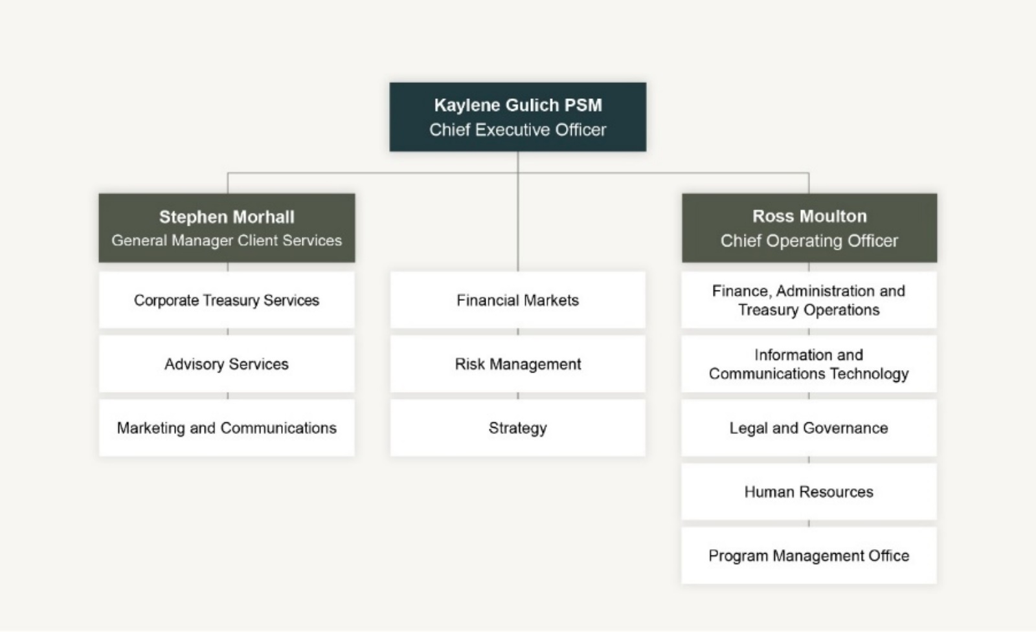

Functional Areas
- Advisory Services - Provides financial risk and corporate finance advisory services to the Western Australian public sector, assisting clients to make informed financial decisions that help them to achieve their objectives, while also realising the overarching goals of the State.
- Corporate Treasury Services - Works in partnership with public sector clients to achieve sound financial outcomes by providing a comprehensive suite of high-quality, cost- effective financial products and services in debt finance, investments, foreign exchange, treasury management, financial risk management and advisory services.
- Finance, Administration and Treasury Operations - Provides accounting, administration, treasury operations, settlements, payroll and business support.
- Financial Markets - Undertakes debt-funding activities in domestic and global capital markets, asset and liability management, management of WATC’s liquidity portfolio, investment management on behalf of clients, foreign exchange management transactions, and economic and financial markets analysis.
- Human Resources - Provides a strategic human resources service to the Board, Executive, branch managers and employees. This service covers all facets of the employee life cycle and is aligned to and supports WATC’s strategic objectives.
- Information and Communications Technology
Provides effective, efficient and secure information management, information systems and technology to support our business operations and deliver on business goals and objectives.

<pp>18
- Legal and Governance - Provides oversight of, and guidance in relation to, the origination and documentation of WATC’s borrowings and other agreements, including financial market and client agreements, and is responsible for ensuring sound corporate governance practices.
- Marketing and Communications - Assists and supports the development, implementation and management of our internal and external marketing and communications activities.
- Program Management Office - Manages a portfolio of projects and initiatives to generate business improvements while maintaining a holistic view on the impact of change across the organisation.
- Risk Management - Measures and monitors market, credit, operational and liquidity risk to prevent adverse outcomes for WATC, provides guidance to the Executive and Board on all risk and compliance matters, and contributes to developing a good risk culture within the organisation.
- Strategy - Develops and progresses strategic initiatives to improve efficiencies and financial outcomes from a State, client and organisational perspective, in relation to our Financial Markets and Client Services activities.

State Guarantee
Under Section 13(1) of the Act, the financial liabilities incurred or assumed by WATC are guaranteed by the Treasurer on behalf of the State. This guarantee is secured upon the Consolidated Account of the State.

Ministerial Directives
No ministerial directives were received during the 2022–23 financial year.

Changes in Written Law
During the 2022–23 financial year there was a consequential change to Section 9 of the Western Australian Treasury Corporation Act pursuant to the Government Trading Enterprises Bill, which was assented to on 22 June 2023.
The Government Trading Enterprises Act 2023 (the GTE Act) came fully into effect on 1 July 2023. The GTE Act enables WATC, among other things, to advise authorities on financial matters referred to in Section 137 of this Act. This change provides flexibility for WATC to advise authorities on business risks associated with prescribed transactions, including hedging transactions pertaining to commodities.

Credit Ratings
In line with the State’s credit ratings at 30 June 2023, the debt of WATC is rated as follows:
Rating Agency | Long-Term | Outlook | Short-Term
Moody’s Investors Service | Aa1 | Positive | Prime-1
S&P Global Ratings | AAA | Stable | A-1+

Subsequent to 30 June 2023, on 11 July 2023 Moody’s Investors Service upgraded Western Australia’s and WATC’s credit rating to Aaa with a ‘stable’ outlook.

<pp>19

Board of Directors
The Board, with the agreement of the Treasurer, sets WATC’s strategic direction and establishes the policies and principles under which we operate.

Michael Barnes PSM, FIPAAWA
Chairperson
Mr Barnes assumed the role of Chairperson when he became Acting Under Treasurer in the Department of Treasury in 2014. Mr Barnes was appointed Under Treasurer in 2015. As Under Treasurer, he is the principal economic and financial policy adviser to the Government of Western Australia. He is also the Chairperson of WATC’s People and Remuneration Committee. Prior to joining the Department of Treasury in 1997, Mr Barnes worked in the Commonwealth Treasury, where he commenced his career as a graduate in 1992. Mr Barnes holds a Bachelor of Business degree with Honours in Economics, and was awarded a Public Service Medal in the June 2020 Queen’s Birthday Honours for outstanding public service to State Government finances in Western Australia.

Michael Court
Deputy Chairperson
Mr Court was appointed to the Board as Deputy Chairperson in July 2017 and has been Deputy Under Treasurer at the Department of Treasury since September 2016. Mr Court has almost 30 years of public sector experience with a focus on economic policy and financial management issues. This includes extensive experience in providing advice to State Government on the budget, fiscal strategy, and infrastructure policy and planning issues, as well as working across Commonwealth-State financial relations, energy market reform, competition and trade policy. Mr Court previously held positions in the Department of Foreign Affairs and Trade, Commonwealth Treasury and London Underground Ltd. He is a former Board Director of GESB and Horizon Power and is currently a member of the Bankwest Curtin Economics Centre Advisory Board.

<pp>20

Kaylene Gulich PSM
Chief Executive Officer
Ms Gulich commenced as CEO of WATC in February 2019. Ms Gulich has extensive experience in public policy, a broad knowledge of financial markets and considerable expertise in the Western Australian economy. She has previously held senior roles within the Department of Treasury as Executive Director of both the Economic, and Infrastructure and Finance business units. As well as being a member of CPA Australia and the Australian Institute of Company Directors, Ms Gulich is currently on the Board of Directors at both the Australian Financial Markets Association and VenuesWest, and is the Treasurer for IPAA WA. Ms Gulich was awarded a Public Service Medal in the June 2021 Queen’s Birthday Honours for outstanding public service to Western Australia through a range of roles.

Philippa Hobson
Director
Ms Hobson was appointed as a Director in February 2020 and is the Chairperson of the Audit Committee and a member of the People and Remuneration Committee. Ms Hobson is a Risk Consulting Partner at RSM in Perth and has over 25 years of internal and external audit and risk consulting experience. Ms Hobson works with clients in the public and private sectors, focussing on internal audit, enterprise risk management and governance services. Environmental, social and governance (ESG), process redesign and cultural reviews are also key services provided. Her industry experience covers government, utilities, resources, not-for-profit and financial services. Ms Hobson is passionate about understanding how an organisation’s culture impacts on its performance and conformance, and strives to support organisations optimising their potential.

<pp>21

Susan Murphy AO
Director
Ms Murphy was appointed as a Director in January 2019. As CEO of Water Corporation from 2008 to 2018, Ms Murphy led the multi-faceted organisation that supplies drinking water to two million customers and wastewater services across 2.6 million square kilometres. Ms Murphy played a pivotal role in ensuring sustainable services were maintained during a time of declining rainfall, growing population and scarce water supplies. In each year from 2009 to 2015, Ms Murphy was listed as one of the 100 most influential engineers in Australia by Engineers Australia. Ms Murphy was appointed an Officer of the Order of Australia in 2019 for distinguished service to the natural resources sector in Western Australia, and to engineering.

Wayne Zekulich
Director
Mr Zekulich was appointed to the Board as a Director in January 2023. He holds a Bachelor of Business and is a Fellow of the Institute of Chartered Accountants. Mr Zekulich is a consultant and non-executive director with substantial experience in advising, structuring and financing transactions in both the infrastructure and resource sectors. Mr Zekulich was previously Chief Financial Officer of Gindalbie Metals Ltd and, prior to that, Chief Development Officer of Oakajee Port and Rail. Currently he consults to a global investment bank, and is Chair of Pantoro Ltd and Openn Negotiation Ltd in the private sector. In the not-for-profit sector, Mr Zekulich is Chair of The Lester Prize.

<pp>22

Agency Performance
- Providing Value to Clients
- Successful Financial Management
- Optimising Our Performance
Image Caption:
Aerial photo of the Shire of Coorow’s Aquatic Centre during construction. Image courtesy of Shire of Coorow.
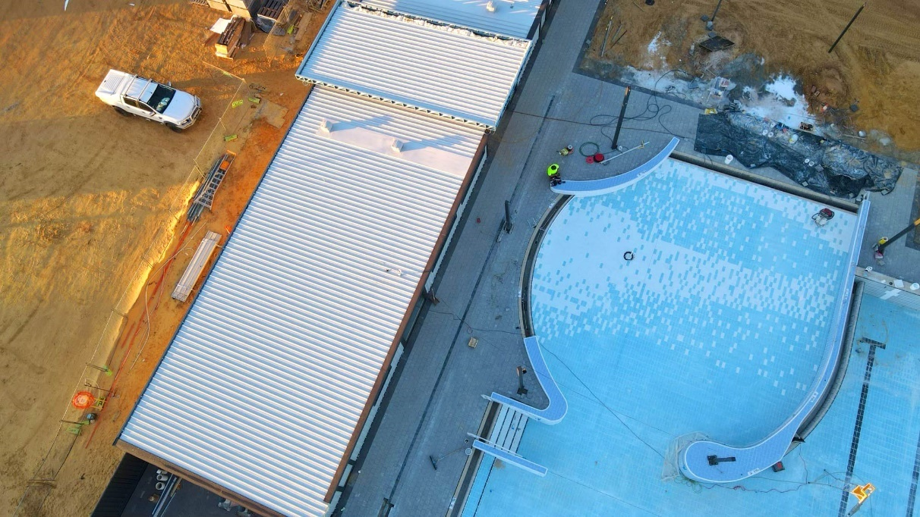
Shire of Coorow
Aquatic Centre
The construction of the Shire of Coorow’s new Aquatic Centre, enabled with debt funding from WATC, will transform the Coorow Recreation Centre and bring significant social and economic benefits to the area and surrounding suburbs.

<pp>23

Providing Value to Clients
At WATC, we deliver a comprehensive range of high-quality, cost-effective financial products and services to our Western Australian public sector clients to support their specific requirements.

Debt Products and Services
Our key outputs include:
- financing for new social and economic infrastructure projects across Western Australia;
- refinancing for existing debt; and
- financing for liquidity and cashflow management purposes.
Our range of debt products cover a wide maturity spectrum in a variety of structures and offer clients flexibility with repayments. By working collaboratively with our clients, we ensure the most appropriate debt products are recommended within the broader State borrowing strategy.

Client Debt
In line with the State’s borrowing program announced in the 2022–23 State Budget, we anticipated an annual net increase of $1.5 billion in client borrowings. However, given the evolving nature of government priorities and initiatives, and the strength of the Western Australian economy, client borrowings actually decreased by $2.9 billion over the course of the year.
Total client debt outstanding at 30 June 2023 was $44.9 billion, down from $47.8 billion at the end of 2021–22. For more information about client debt outstanding see page 110.

Image Caption:
Graph showing the increase in WATC Client Debt from 1986 to 2023. Source data courtesy of WATC.
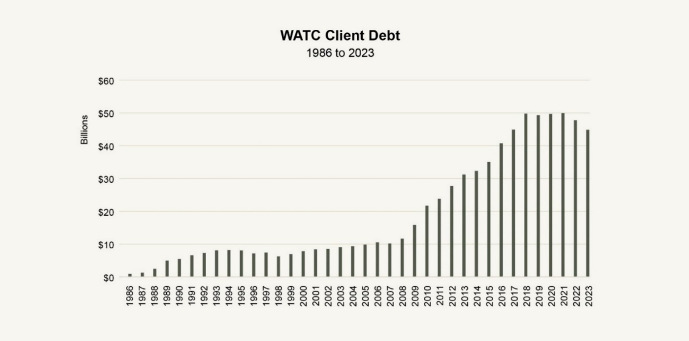

<pp>24
FOCUS

Local Government Lending
Objective
To support responsible and financially sustainable lending within the local government sector.
Lending Framework Reform
As the primary term-debt funding provider for local governments across Western Australia, WATC is committed to supporting local communities through responsible and financially sustainable lending to the local government sector. Following a comprehensive review, changes were made to our local government lending framework to provide a more holistic credit assessment of our local government clients and ensure WATC can continue to support the financial sustainability of the sector over the longer term.
The changes, which took effect on 1 July 2022, were delivered to clients via a comprehensive transition plan. This plan included a range of communications along with educational presentations and webinars, eLearning resources and responses to address frequently asked questions.
Outcome
As at 30 June 2023, the total debt outstanding with WATC by Western Australian local governments was $642.3 million, a net increase of $39.5 million during the 2022–23 financial year. In the same period, we approved 58 new loans totalling $152.1 million for our local government clients.
Image Caption:
Photo of public garden and art in City of Canning. Image courtesy of City of Canning.

<pp>25

Looking Forward - Government Trading Enterprise Reform
The Government Trading Enterprise (GTE) Reform Program was established by the Western Australian Government in 2018 to review the governance arrangements of GTEs, develop a framework to standardise accountability, and strengthen the connection between GTEs and the Western Australian government.
After extensive research and consultation, the Department of Treasury developed and implemented the Government Trading Enterprises Act 2023. Commencing on 1 July 2023, this Act will impact GTE entities across Western Australia, including WATC.
Sections of the Western Australian Treasury Corporation Act 1986 are impacted by the GTE reforms and we continue to work closely with the Department of Treasury to ensure a seamless transition to the new framework. Ultimately, the reforms will enable us to support clients to evaluate and manage a wider range of business risks including commodity risk which was excluded under the previous legislation. WATC will work with clients to identify and better understand these risks, quantify the financial impact and sensitivities, and explore mitigation strategies available.

Advisory Services
The Advisory Services team at WATC provides independent expert advice on corporate and financial risk management, supporting clients to make better-informed financial decisions. Team members deliver high-quality, streamlined financial analysis, modelling and scenarios, and work collaboratively with clients to ensure better outcomes for both them and for the State.

Client Engagements
Advisory engagements integrate WATC’s expertise, experience and public sector understanding with the unique business knowledge of each of our clients. Over the last financial year, we completed 50 client engagements, and are progressing a further 13 engagements, covering a wide range of clients and projects including analysis to assist in delivering new State infrastructure.
As part of our client engagements, we delivered:
- Project Finance Advice and Modelling - In order to provide clients with a clearer vision of their financial sustainability, we developed and validated financial models and simulations, evaluated asset and project investments and assisted with analysing project financing options.
- Business Case and Cost Benefit Analysis - We developed comprehensive financial analysis for business cases to support client project investment decisions and evaluate investments and assets, as well as determine appropriate pricing frameworks for clients operating in regulated environments.
- Asset and Liability Management - We provided debt structure analysis and advice, asset-liability modelling and investment policy guidance to assist clients to effectively manage their debt and financial risks.

<pp>26
FOCUS

Appointment to Infrastructure WA Panel
Background
Infrastructure WA (IWA) is responsible for evaluating State Government infrastructure proposals that cost over $100 million. During the 2022–23 financial year, IWA invited a range of specialist financial and engineering consultants from around Australia to apply for a position on its Advisory Panel, with WATC selected to be part of the IWA Panel.
Appointment
The appointment to the IWA Panel recognised that our Advisory Services team has the skills and experience required to:
- work across 15 different economic and social infrastructure sectors;
- provide complex financial and economic modelling; and
- undertake transport and infrastructure modelling.
As a leading infrastructure-focused financial adviser in Western Australia, WATC has substantial experience in successfully advising government agencies and government trading enterprises on a wide range of infrastructure matters including business cases, benefit– cost ratios and proposals, as well as providing expert consultation and advice to key stakeholders including IWA, the Department of the Premier and Cabinet, and the Department of Treasury.
WATC has either advised on, or reviewed, close to a quarter (6 out of 26) of Western Australian projects on the Infrastructure Australia Priority List, and directly advised on two successful admissions to this list.

Image Caption:
Photo of Fremantle Port. Image courtesy of Fremantle Ports.

<pp>27
CASE STUDY

Long-Term Financial Planning
Objective
To support better long-term financial planning for local governments.
Client
A regional local government client was seeking assistance to develop a long-term financial plan (LTFP) model to support its integrated planning and reporting framework, and accurately evaluate infrastructure and service level plans within its budget framework.
Outcome
We developed a LTFP model solution which included the following functionality:
- a scenario selector to assess self-funding service- level sensitivities, providing the ability to flex variables and evaluate divisions based on standalone financial results;
- a suite of dashboards for effective scenario testing, decision making and reporting that also met council presentation and internal reporting requirements;
- graphs to address asset management plan requirements and provide support for critical capital investment decision making; and
- calculations of Financial Health Indicator ratios to provide insight into the Shire’s financial sustainability.
By engaging WATC to develop an excel-based LTFP model, the local government client successfully enhanced its capacity for budget and infrastructure planning, rates forecasting and financial management. The model enabled assessment of growth assumptions, scenario evaluation and analysis of long-term financial and asset sustainability.
Following WATC’s development of a step-by-step user guide for updating data inputs and assumptions, the client’s finance team now use the model as a key resource to support their budgeting, planning and reporting processes.
Quote
“The WATC Long Term Financial Plan…is a great multi-functional model which can be as simple or as detailed as we need it to be. Will serve its purpose for many years to come.”
Direct Client Feedback
Image Caption:
Photo of Bullara Station. Image courtesy of Tourism Australia.
<pp>28

Foreign Exchange Services
Our foreign exchange services provide clients with access to a range of products and tools to help identify, measure and manage their foreign exchange exposures in compliance with Treasurer’s Instruction 826.
WATC has direct access to wholesale foreign exchange markets, multi-currency funds settlement systems, capital market information and treasury management systems. Combining these systems and data with our experience and expertise ensures clients are fully supported and aware of their foreign exchange risks and can make informed decisions in terms of materiality and management. During the financial year, we executed in excess of $550 million in foreign exchange transactions in 10 currencies and on behalf of 18 clients.

Asset and Investment Management Services
WATC assists in managing State and client finances by providing investment products and treasury management services. These products and services are tailored to suit specific business requirements and assist in managing financial risks, including interest rate and credit risks.
We also undertake research and development of investment product opportunities to assist clients in managing their short to medium-term investment needs.
Clients benefit from our considerable experience and expertise, systems, pricing and oversight that come with our scale of operations within the financial markets.

Managed Investments
Total client funds under management at 30 June 2023 was $6.7 billion across five investment portfolios. We managed each of these investment portfolios in accordance with client-approved policy frameworks that included defined risk parameters and performance benchmarks. We also provided back-office trade capture and reporting on treasury management services for two clients.

<pp>29
FOCUS

Client Feedback
Continuous development and improvement are both extremely important to us here at WATC, and we regularly seek feedback to ensure our products and services add value to our clients and align with their requirements. During May and June we engaged Peter Lee Associates, a research and consulting firm specialising in financial services, to independently survey WATC’s State Government clients. Results were “exceptionally strong” for WATC this year, with responses confirming:
- our offerings were closely aligned to client needs;
- transactions with us were efficient and cost effective;
- client service evaluations were measurably stronger than in previous years;
- we added value across all client segments; and
- we met our objective to provide high-quality, cost-effective products and services to the Western Australian public sector.
In addition to the independent survey, we sought direct client feedback on advisory engagements as soon as they were completed. As with previous years, the results for the 2022–23 financial year were extremely positive. Clients expressed very high levels of satisfaction on the quality of advice provided, the value added to their projects and the team’s overall capability and service.
The effectiveness of our Advisory Services team has also been apparent in client re-engagement levels. Existing clients regularly appoint our team to work on new projects, providing further evidence of our ongoing effectiveness.
Image Caption:
Photo of building in the Town of Port Hedland. Image courtesy of Town of Port Hedland.
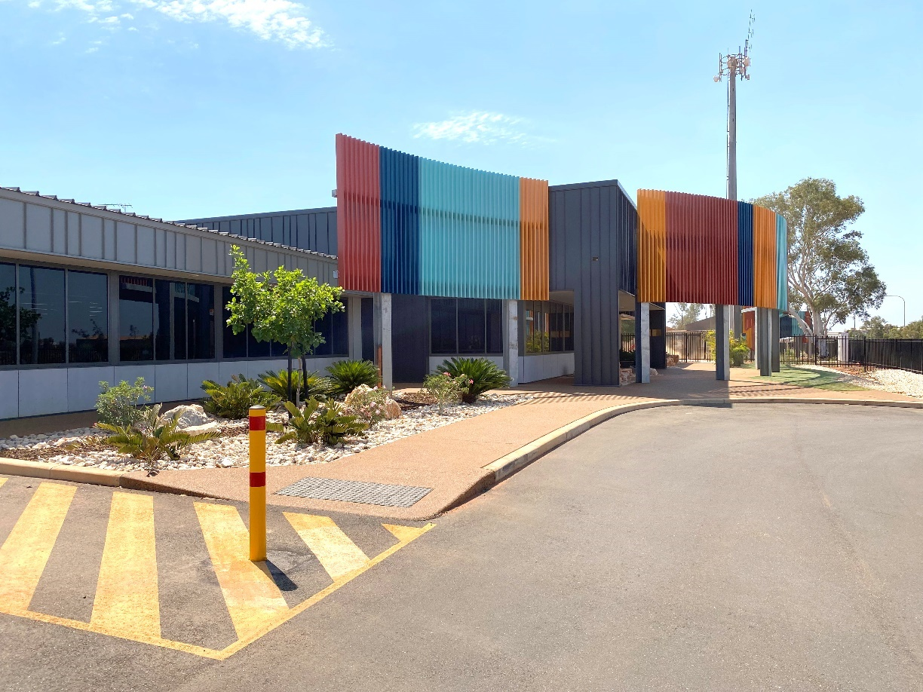
<pp>30
FOCUS

Client Education
Objective
To engage and inform clients across the Western Australian public sector.
Outcome
We engaged over 300 client contacts through our education and training programs, which included:
- Foreign Exchange Seminars
Four seminars were held to increase awareness and understanding of foreign exchange risk management issues. A total of 69 client contacts attended from organisations across the public sector.

- Economic Presentations
Two presentations were held with chief economists from major Australian banks who presented their views to our clients and the WATC team on interest rates, currencies and the economy. Additionally, our in-house Chief Economist, Craig McGuinness, delivered an online economic presentation providing valuable insights into the global drivers affecting the Western Australian Government’s infrastructure projects and technology procurements. Over 200 client contacts attended the various economic presentations. WATC economists also provided numerous economic presentations and briefings to client organisations, enabling a focus on their specific areas of interest.

- Industry Events
We hosted our public sector clients at various industry events throughout the financial year. The selected events included presenters and topics that aligned with WATC’s services and the roles of the client contacts who attended.
Image Caption:
Photo of Craig McGuinness, Chief Economist at WATC presenting. Image courtesy of Mladen Zaneta.
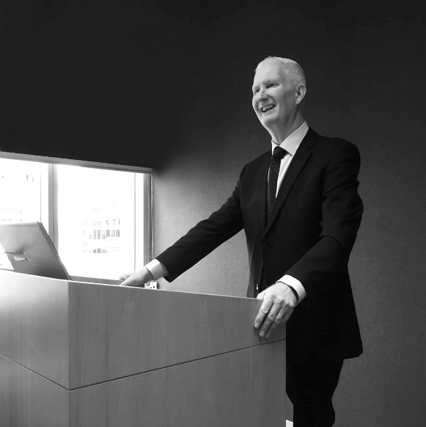

<pp>31

Successful Financial Management
To deliver on State borrowing requirements and meet our clients’ evolving financing needs, WATC continues to be flexible and adaptive, an approach that has been essential to managing increased volatility and uncertainty in financial markets.
In sourcing funds to meet client debt financing requirements, we borrow from domestic and international capital markets, both of which continue to be impacted by the threat of increasing inflation and central bank policy tightening cycles.
At WATC, these impacts were felt mainly through increased volatility and higher yields in the financial markets. Our adaptability ensured that, despite these challenges, we successfully managed and delivered on all client borrowing, refinancing and repayment requirements during the financial year.

Economic and Market Conditions
Although it remains uneven, global economic growth picked up in early 2023 following subdued growth in the second half of 2022. The uplift was led by a strong rebound in China as pandemic- related restrictions were lifted in late 2022. The easing of supply chain disruptions and falling energy prices also helped improve activity.
However, the Chinese economy lost momentum in the second quarter and tighter monetary policy is working to slow economic activity growth in the developed economies. The latest International Monetary Fund forecast from July 2023 predicts full-year global economic growth to slow to 3.0% in 2023 from 3.5% in 2022.
Inflation rates have fallen from the multi-decade highs reached in 2022 but remain elevated across most of the major economies, except for China. Central banks raised interest rates sharply over the course of 2022–23 to rein in inflation. While central banks appear to be close to, if not at the end of, their tightening cycles, with core inflation remaining sticky and labour markets tight, further interest rate hikes cannot be ruled out.
The rapid central bank interest rate increases, together with high inflation, drove a substantial rise in the cost of new borrowing to the highest levels in a decade, both in Australia and overseas. In early 2023, increases in interest rates also drove some instability in the US regional banking system.
Australian economic growth remained solid in the second half of 2022. However, growth slowed sharply in the first quarter of 2023. This is likely to slow further as high inflation and rising interest rates continue to take their toll on real household disposable income and spending, despite strong employment growth and unemployment remaining at near 50-year lows. The Reserve Bank of Australia (RBA) raised the cash rate target by 400 basis points to 4.10% between May 2022 and June 2023, reaching the highest level in over a decade. While the RBA has had some success in lowering the rate of inflation from the more than 30-year highs of late 2022, the annual consumer price index (CPI) inflation rate remained elevated at 6.0% in the June quarter of 2023, well above the 2–3% target band. The RBA, like other central banks, is likely to be nearing the end of its hiking cycle. However, with the labour market very tight and productivity growth weak, the RBA is alert to the risks of higher wages growth spilling over into a further uplift in inflation.
Western Australia’s strong domestic economy and record high merchandise exports of $270.4 billion in 2022–23, saw the State unemployment rate remain very low in June 2023 at 3.6%, with the labour force participation rate of 68.5% well above the national average.

<pp>32

Financial Market Activities

Flexibility During Uncertainty
Following the release of the 2022–23 Western Australia State Budget in May 2022, we announced our 2022–23 borrowing program which highlighted an estimated $1.5 billion increase in client borrowings. However, reflecting the strong fiscal position of the State, we saw client borrowing decrease by $2.9 billion over the course of the year.

Delivering on Client Requirements
Notwithstanding the positive impacts of the State’s strong fiscal position allowing for significant debt reduction, WATC continued to be active across all elements of financial markets through reverse enquiry, tenders and syndications. In doing so we delivered on all client requirements and:
- successfully completed our yearly funding task while managing an overall reduction in bonds and floating rate notes (FRNs) outstanding due to debt repayments;
- launched and priced a new five-year FRN as part of our borrowing program; and
- marketed, launched and priced WATC’s first green bond.
The new five-year FRN was issued in January 2023 by syndication with an 8 March 2028 maturity. The issue launched and priced on the same day, generating strong investor demand. At close, total bids exceeded $5.0 billion, the largest order book for a single maturity FRN issue in Australia. The final issue of $1.0 billion was allocated across 23 institutions and was well supported by domestic bank balance sheets and asset managers, with 97.5% going to domestic investors.
Funding for liquidity and short-term requirements continued to be met through our Domestic Short-Term Inscribed Stock and our Euro Commercial Paper Program.

State Bonds
WATC offers State Bonds to individual investors and to those seeking to purchase State Bonds as a designated investment as part of their application to migrate to Australia. At 30 June 2023 there was $173 million in State Bonds outstanding.

Credit Ratings
At 30 June 2023 WATC’s borrowings were afforded strong credit ratings, being rated AAA by S&P Global Ratings and Aa1 by Moody’s Investors Service. For more information on our credit ratings, please refer to page 18.
Image Caption:
Graph showing WATC’s Maturity Profile as at 30 June 2023. Source data courtesy of WATC.
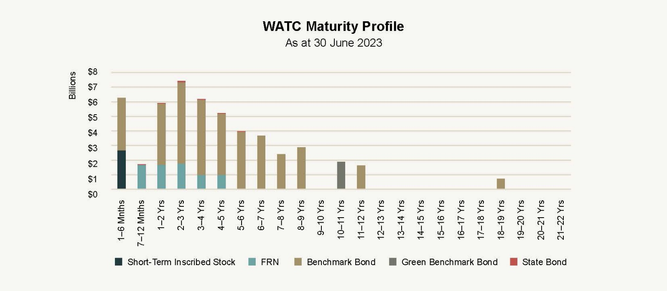
<pp>33

Looking Forward: Credit Rating Upgrade
In July 2023, Moody’s Investors Service upgraded Western Australia’s and WATC’s credit rating to Aaa, with a ‘stable’ outlook. This is the highest possible credit rating and followed a similar upgrade by S&P Global Ratings in June 2022. Strong financial management, sustained budget surpluses and easing in State debt were highlighted as contributing factors to the upgrade. At the time of the Moody’s Investors Service upgrade, Western Australia was the only state or territory in the country to have the top credit rating from both major international ratings agencies.

Investor Engagement
In May 2023, following the release of the 2022–23 Western Australian State Budget, former Western Australian Premier and Treasurer, Mark McGowan, along with Under Treasurer, Michael Barnes, and WATC CEO, Kaylene Gulich, presented to domestic investors and market intermediaries in Sydney. Key highlights included information on the State Budget and new initiatives, plus data on Western Australia’s economy, export performance, business investment and labour market.

Looking Forward: Investor Conference
WATC will host domestic and international delegates later this year in association with the Commonwealth Bank Global Markets Conference. The event, scheduled for October, is designed to showcase the economic diversity, sustainability initiatives and industry innovation found across Western Australia and will include presenter-led sessions, one-on-one interactions and site visits in both regional and metro locations.

Ongoing Plans for Successful Financial Management

Looking Forward: Economic Outlook
Although central banks, including the Reserve Bank of Australia, are near the end of their tightening cycles, monetary policy works with a lag and the impact of higher interest rates will be an increasing drag on global growth in 2023–24.
Domestically, growth in the Australian economy slowed sharply in early 2023, led by a fall in household spending growth. Household spending is expected to remain under downward pressure in 2023–24 as higher interest rates continue to eat into household cash flows.
High levels of household debt mean that a rise in unemployment could flow through to a sharp increase in loan arrears, which may have implications for financial stability.
Western Australian economic growth is expected to moderate in 2023–24, primarily due to an easing in household spending growth and slower export growth. This will be offset by stronger growth in private business and public sector investment. While the State is vulnerable to developing global headwinds, strong economic fundamentals mean the State is well positioned to withstand potential challenges.

<pp>34
FOCUS

Sustainability Bond Framework Release
After more than two years of coordinating related work across a range of Western Australian government agencies, we released our Sustainability Bond Framework (Framework) in May 2023. Following the launch, we announced an intention to participate in the sustainable finance market through issuance of an inaugural green bond in accordance with the Framework.
Key objectives of the Framework include supporting the State’s commitment to the Paris Agreement to reach net-zero greenhouse gas emissions by 2050 through providing meaningful information on decarbonisation initiatives, and progressing the objectives of the United Nations’ Sustainable Development Goals.
To support the release of the Framework, an intensive investor engagement program was completed in late May where WATC representatives met with 69 domestic and offshore institutional investors across 12 cities. The program aimed to raise awareness of WATC’s participation in the sustainable finance market, highlight the connection between our sustainable finance program and the Western Australian Government’s broader environmental, social and governance (ESG) credentials, and expand the Western Australian Government’s investor base to include investors specifically seeking an ESG-labelled issuance.
The success of the program was clearly demonstrated by the high engagement level from the investors, who submitted a total of 297 written questions about the Framework and planned issuance.
Highlights:
- 12 Cities in 12 Days - WATC representatives met with investors in 12 cities, either in person or virtually, to raise awareness of the Sustainable Finance Program.
- 69 Investors Engaged - To promote the program, we met with 69 domestic and offshore institutional investors. Attendees submitted nearly 300 written questions.

<pp>35
FOCUS

Successful Green Bond Issue
Following the investor engagement program, WATC’s first green bond, which launched on 8 June 2023, was a resounding success. The issuance was heavily oversubscribed, receiving more than $6 billion in investor bids (25% of which were from offshore investors) for the $1.9 billion issued. Due to the volume of demand, the initial price guidance was reduced during the issuance process with a substantial number of new investors participating, including those requiring green bond certification.
WATC’s first green bond issuance was covered extensively by a range of mainstream, financial and environmental news outlets who reported positively on the milestone.

Highlights:
- $6.0b+ in Bids - Our first green bond was more than three times oversubscribed, with over $6 billion in bids for the $1.9 billion issued.
- 24 New Investors - Of the participating investors, 24 were new institutional investors who had no activity with WATC in the last five years.

Looking Forward: Supporting Our Inaugural Green Bond
To support our green bond issue, we are committed to publishing an annual sustainability bond framework report which will include details on how proceeds were allocated to eligible projects together with detailed project descriptions, their delivery status and impact indicators. The report will be available on our website.

<pp>36

Looking Forward: Estimated Borrowing Program
The new money program for 2023–24 is estimated at $0.5 billion. In addition, there is approximately $5.3 billion of maturing benchmark bonds and FRNs, of which $0.5 billion has been pre-funded. This results in a gross term funding program of $5.3 billion for 2023–24.
The sourcing of WATC’s funding is subject to various market conditions and the market mix during the year. Funding may be amended, as necessary, to meet our pricing, liquidity and lending targets. The WATC forecast borrowing program across the forward estimates period is detailed in the following table:
Term Funding Requirement | 2023–24 $b | 2024–25 $b | 2025–26 $b | 2026–27 $b
New Money Program (Est.) | 0.5 | 0.7 | 0.5 | 0.6
Projected Maturities | 5.3 | 5.9 | 7.4 | 6.0
Less Pre-Funding | -0.5 | 0.0 | 0.0 | 0.0
Total Maturities + New Money | 5.3 | 6.6 | 7.9 | 6.6
Debt Repayment | 0.0 | 0.0 | 0.0 | 0.0
Total Term Funding | 5.3 | 6.6 | 7.9 | 6.6

Looking Forward: Funding Strategy
We plan to deliver on the State’s funding and debt management requirements for 2023–24 by:
- considering opportunities to issue up to two new FRN maturities in the 5–7 year maturity range, while continuing to issue into outstanding FRN maturities, in response to investor demand and to meet the floating rate borrowing requirements of clients; and
- seeking to establish a new benchmark bond line with the aim of filling the gap in our bond maturity curve at the 2032 point, subject to refinancing and New Money requirements.
In addition, we will continue to:
- issue across the yield curve to fund lending to clients;
- build volume in existing benchmark bonds to enhance liquidity in those lines;
- support activity in our bond lines, where possible, in the market; and
- issue through our Fixed Interest Dealer Panel through reverse inquiry, taps, tenders and by syndication.
We aim to meet short-term funding and liquidity requirements by maintaining approximately $3.5 billion of short- term paper on issue through our domestic Short-Term Inscribed Stock and offshore Euro Commercial Paper Program. We will also ensure that debt issuance undertaken through our various funding programs is issued in a manner that satisfies the requirements for an exemption from interest withholding tax under Section 128F of the Income Tax Assessment Act 1936.

<pp>37

Optimising Our Performance
At WATC we are committed to continually improving our systems, capabilities, and processes to ensure we achieve our vision, deliver on our core objectives, and provide value to our clients and the State.
We strive to optimise our performance in accordance with the Western Australian Treasury Corporation Act 1986. Operating in a dynamic environment, we are continually faced with a range of risks and opportunities. We manage these by working within our Board-approved risk management and compliance framework, which provides a clear governance structure for our operations.

Managing the State’s Liquidity
In managing the State’s financial assets, and liabilities, we work closely with the Department of Treasury and our clients to ensure the State’s liquidity is effectively managed. Our Board monitors key debt metrics for both WATC and the State to ensure the ongoing effective management of our balance sheet and the State’s liquidity. During the 2022–23 financial year, the State maintained elevated levels of liquidity ensuring the targets for our debt metrics were met.
Highlights:
- 16% Debt Maturing Within 12 Months
  - Target: Less than 20%. Result: Target achieved
- 234% Liquid Asset Portfolio Cover
  - Target: Greater than 100%. Result: Target achieved

Risk Management
We operate in a dynamic financial market environment that presents both opportunities and risks that could materially impact our operations and our ability to meet our responsibilities. Our business is exposed to a wide range of risks associated with our operations, including market, credit, liquidity, funding, operational, reputational and strategic risks.
We have Board-approved risk management and compliance frameworks that, together with our corporate governance and organisational systems and processes, provides a sound structure for identifying, assessing, managing, monitoring and reporting material risks.
Our achievements for 2022–23 were all successfully managed and delivered within our Board’s approved framework and risk appetite.

Enhancing Our Risk Management
Over 2022–23, we continued to evolve and mature our approach to enterprise risk management and strengthen how we identify, assess, communicate, manage and analyse risk across the organisation. This also included improvements to our systems and processes. As part of the Local Government Lending Reform we have refined and updated our credit assessment process to provide responsible lending to the sector.
Our management risk committees continue to provide oversight of both the current and emerging risks WATC is facing. WATC’s Asset and Liability Committee, which considers financial risks, has over the year ensured the adequacy of our risk management settings in a more challenging credit environment and through continued market volatility.

<pp>38
Our Operational Risk and Compliance Committee, which is in its second year of operation, continues to generate valuable, enterprise-wide oversight and continuous improvement, and evolve the management of our non-financial risks, processes and procedures.

Improving Our Operations

Value Improvement Program
WATC has an embedded, formalised advancement pathway through our Value Improvement Program, which utilises Agile business process improvement tools, techniques and strategies to review and enhance system and non-system processes.
Over the course of the financial year, all of our high- business-value improvements across all branches were prioritised and delivered. Highlights of this year were significant improvements to corporate reporting dashboards that allowed greater visibility of product performance. Remaining improvements are expected to be enabled through the upgrade to our core treasury system, planned for 2023–24.

Change Advisory Board
Since its introduction in the 2021–22 financial year, the Change Advisory Board (CAB) has provided a new approach to support system change management at WATC. The CAB makes decisions on which system changes to progress, based on the highest value delivery in the shortest time. During 2022–23 the CAB assisted in the assessment, prioritisation, authorisation, resourcing and scheduling of several system changes that improved efficiency and effectiveness across WATC.

Digital Information Management
Our Digital Information Management project aims to develop a high-level strategy and priority roadmap to further improve information management and move towards better ways of working by:
- ensuring our information is well-structured, enabling greater access and collaboration;
- reducing the risk of information loss; and
- managing our information security and compliance within the requirements of the State Records Office of Western Australia.
The first phase of the project, which comprised of an extensive review of our information sources, systems and assets, was completed in 2022. From this research, we developed an information architecture prototype and governance framework during 2022–23, which is being tested to ensure business alignment and usability. The results of the initial tests have been positive and will be used to guide future deployments across the organisation.

Efficiency and Cost Effectiveness
We use our Administration Cost Ratio Key Performance Indicator to ensure we are delivering high-quality products and services while still being a cost-effective solution for our clients. This ratio allows us to monitor our administrative efficiency and the cost effectiveness of funding client borrowing. It measures the average administrative on-cost that must be borne by our clients. In 2022–23 we achieved an Administration Cost Ratio of 0.040%, which was below our target of less than 0.050%, affirming our cost-effectiveness while delivering value to clients and the State. See Key Performance Indicators on page 103 for more details.

Information and Communications Technology

Cyber Security
Information and communications technology is critical to our operations and ongoing success. With the ever-increasing risk of cyber threats and attacks, we continue to escalate our focus on cyber security. Using mitigation strategies such as the Essential 8 alongside the ISO 27002 control framework has ensured that WATC is continuing to mature its cyber security posture in the prevention, detection and response to security threats.

Looking Forward: Optimising Performance
As part of the implementation of our new Technology and Change Strategy, in 2023–24 we will be focussing on:
- further maturing our cyber security capabilities;
- continuing to optimise our information systems; and
- improving our digital information management.
We will also continue to evolve our approach to risk management and expand our Value Improvement Program across our organisation.

<pp>39

Disclosures and Legal Compliance
- Managing Our Information Assets
- Our People
- Board of Directors’ Governance
- Board Committees
- Legislation
- Corporate Governance

Image caption: Representation of Saltwater Busselton. Image courtesy of City of Busselton.
City of Busselton
Saltwater Busselton
The City of Busselton is building Saltwater Busselton, a state-of-the-art performing arts and convention centre, opening in 2024. Supported with debt funding from WATC, Saltwater Busselton is set to be a central hub for the region’s significant creative industry as well as a prime destination attracting world-class business events and entertainment to the region.

<pp>40

Managing Our Information Assets
Information is critical in supporting our business activities and is managed in accordance with the State’s records management requirements.

Information Management
Data, information and records are all managed as valuable assets that are critical to the success of our operations. All information assets are captured and managed according to our business needs, ensuring the relevant information is readily accessible and appropriately secured if sensitive.
We have an approved recordkeeping plan in accordance with Section 19 of the State Records Act 2000 (State Records Act), which meets the requirements of Standard 2, Principle 6. We manage our records under the Recordkeeping Plan (RKP) 20200032, which was approved by the State Records Office of Western Australia on 26 March 2021 and is valid until March 2026.
Our information management policies and procedures are regularly reviewed and updated as required, as part of our ongoing information governance processes.
WATC continues to adopt a flexible working environment including remote working opportunities. These opportunities are further enhanced through applications for managing digital information in a safe and secure manner.

Recordkeeping Training
Our recordkeeping induction program for new team members continued with all 17 new starters completing the program within two weeks of their commencement date, in line with our policy. During the year we redesigned our recordkeeping induction program to enable online delivery, providing greater flexibility to accommodate remote working. Our new program is a combination of:
- An initial introduction and overview of our records and information framework, including where and how to find information.
- An audio guided online learning module introducing our information management policy and outlining employee responsibilities and requirements. Once the module is completed, a quiz is used to embed understanding.
- A facilitated practical workshop on how to use our electronic document records management system. After completing the workshop, our Information Management Officer meets with new team members to see how they are finding using the system, answer any of their questions and obtain feedback on their induction.
In accordance with our policy, our people undertake records awareness refresher training every two years. During the year we identified specific staff needs in this area and updated our refresher training program accordingly.

<pp>41

Digital Information Management Strategy and Roadmap
In 2022, extensive research was undertaken to determine the best way to implement digital information technologies and applications as part of our high-level Digital Information Strategy and Roadmap. A prototype information architecture design was developed and refined to meet compliance requirements and WATC usability needs. The prototype has been implemented as part of a pilot program with learnings incorporated into future project deployments.
Key achievements on the roadmap this year include the development of the information architecture and governance framework. A staged rollout and change management program is now underway.

<pp>42

Freedom of Information
The Freedom of Information Act 1992 (FOI Act) enables the public to apply for access to documents held by WATC. Guidance on how to apply and obtain requested documents is set out in our Information Statement, which is available via our website. The statement is prepared in accordance with the requirements of the FOI Act and is regularly reviewed and updated.
We received one FOI application and one third-party consultation during the financial year. These were both processed in accordance with the FOI Act and our FOI Policy, and within the required timeframes.

Refreshed Website
In March 2023 WATC launched a new website, which was the culmination of nine months of project work, extensive research and stakeholder consultation. The solution delivered a more intuitive and simplified information architecture, refreshed modern design and more dynamic system. Additionally, following the upgrade to the content management system, the security profile of the website has been much improved, ensuring that WATC’s public content is not only more accessible and searchable, but also better protected. The new website has been well received by the public, with user traffic increasing significantly since the launch.

Implementation of New Accounting System
During the 2022–23 financial year, WATC successfully implemented a new accounting system. As part of the implementation, we worked closely with our internal and external auditors to ensure a smooth transition. The new system features increased functionality and has enabled improvements to our financial management while also delivering efficiencies in processing and enhanced reporting capabilities.

Looking Forward: Our Plans for Managing Information
As part of our Digital Information Strategy and Roadmap for 2023–24, we will continue to progress the design, implementation and user adoption of our new Microsoft 365 information architecture, together with improving our internal communications and recordkeeping.

Complaints
We are committed to providing an accessible, fair and efficient complaints management process. Our Complaints Management Policy is informed by guidance issued by the Ombudsman Western Australia. This includes the appointment of a dedicated Complaints Officer who is responsible for impartially assessing complaints and notifying our Chief Executive Officer about those received and the progress towards a resolution. The policy stipulates strict timeframes for responding to and resolving complaints. We regularly review our complaints policy to ensure it remains current and is easy for users to navigate. There are multiple ways to lodge a complaint, including an online form on our website, by mail, by email or in person.
Complaints, though rare, are viewed as an opportunity to improve our business operations and staff development. We received no complaints in the 2022–23 financial year.

<pp>43

Our People
An engaged and capable workforce, one that is aligned to our values and invested in delivering our strategic and operational goals, is essential to the continued success of our organisation.

Our Team
Acknowledged by both clients and stakeholders, our workforce is capable, experienced and possesses high levels of professionalism, expertise and technical ability. To maintain and enhance these capabilities, the WATC team is supported with learning and professional development opportunities covering both technical and interpersonal skills.
During the financial year, we increased our staff numbers from 81 to 88. The increase was to cover parental leave, project work or staff temporarily allocated to other roles, and to fill a backlog of long- term vacancies.
People Profile | 2022–23 | 2021–22
Number of WATC staff at 30 June | 88 | 81
Full-Time Permanent | 75 | 69
Full-Time Temporary | 5 | 2
Part-Time Measured on a Full-Time (FTE) Basis | 5.16 | 6.46
On Secondment | 0 | 0

Significant Contributors
During 2022–23, several long-serving team members retired or transitioned to other employment. With a combined tenure of over 160 years, the collective knowledge and experience of these former colleagues is immense and will be missed. We would like to express our appreciation and acknowledge the significant contributions made to both WATC and the State by:
- Adrian Koelewyn, Chief Dealer Offshore Markets and Funds Management
- Steve Luff, Chief Financial Officer
- Bill McEwen, Technical Specialist
- Julia Tyzack, Chief Accountant
- Geoff Williams, Manager Asset and Liability Management
We wish them well in their future endeavours and thank them for their contributions and the positive legacy they leave behind.

Improving Staff Engagement
We strive to create an environment where our people are encouraged and supported to do their jobs to the very best of their abilities. We have a key performance indicator that measures staff engagement through a confidential annual staff survey. During 2022–23 our staff engagement rating was 66%, a slight decrease on previous years’ results. We are working to improve this rating with a range of initiatives and strategies, many of which are outlined on the following pages.

<pp>44

Working at WATC
Careers at WATC are a rewarding endeavour that offer interesting and challenging work in a collaborative workplace culture. We recognise the diversity of our team as an asset that provides a variety of perspectives and cultural experiences. We are proud of our inclusive culture and strive for constant improvement through open and respectful communication.
At WATC we offer a range of benefits, beyond remuneration, that appeal to both prospective and current employees. This year we reviewed and improved how we articulate and communicate these benefits, in and outside of our organisation.
For external audiences, the Careers page of our new website was designed around the journey prospective employees would take, highlighting our value proposition and pertinent information.
Internally, we communicated key information with the team through all staff presentations and the development of our HR Matters communications site. HR Matters is the platform where employees can access staff programs, initiatives and benefits, some of which are outlined in the following highlights.

Diversity and Inclusion Plan - This year, WATC launched its diversity and inclusion plan as part of our journey to better inclusivity. This included a range of sessions and events to drive First Nations awareness, reinforce our role in reconciliation and broaden our collective perspective. Interactive sessions included an Acknowledgement of Country workshop, a Living with Disability presentation, and training in unconscious bias.
Supporting Women in Finance - At WATC we are actively working to attract women to the financial sector. Of the new staff joining our team during the 2022–23 financial year, 41% were women, increasing our overall female representation by close to 10%. In March we celebrated International Women’s Day with a panel discussion in collaboration with the Department of Treasury, further recognising and acknowledging the contributions of women in finance.

<pp>45
Continuous Learning and Development - WATC team members are encouraged and supported to undertake professional development, training courses, professional memberships and structured learning to develop their skills and abilities. During the year we introduced individual development plans for all staff. Prepared in conjunction with managers, the plans identify opportunities to enhance current skills and build new capabilities.
New Reward and Recognition Program - Early in 2023, we relaunched our Reward and Recognition Program based on feedback, best practice and ongoing consultation. The new program supports employee connection and features a wider range of categories to recognise individual and branch contributions, major initiatives, tenure, and more. Since relaunching the program, the number of monthly nominations recognising individual staff contributions has increased by 300%.
Flexible Working Arrangements - Our flexible working policy provides our people a variety of working arrangements, including working from home, flexible start and finish times, compressed work schedules, part-time work opportunities, and more. Since the new policy was implemented, 65% of our people have established regular working-from-home arrangements.
Health and Wellbeing Calendar - In addition to our ongoing wellbeing initiatives, including our employee assistance program, gym and fitness classes, flu vaccinations, skin cancer screenings and health checks, we rolled out a new wellbeing calendar this year. The initiative focussed on a new topic each month, which was specifically chosen to improve team health and mindfulness.

Graduate Program
WATC regularly accommodates short-term placements for newly employed graduates from Western Australian Government agencies. The placements with WATC provide graduates with an understanding of our role within government and financial markets while exposing them to a variety of development opportunities.
During 2022–23, we hosted two graduates who worked on a range of projects while spending time with our Economics and Advisory Services teams. During their rotation with us, and in addition to contributing to projects that supported our clients and the State, we assisted the graduates to develop their skills in modelling, financial analysis, reporting and presenting financial information.

<pp>46

Safety Legislation
We are committed to providing a safe and healthy working environment that promotes wellbeing and complies with the relevant legislation. We continued to align with the Work Health and Safety Act 2020 and regulations that came into effect during March 2022, ensuring that everyone remains aware of their responsibilities and obligations.

Annual Performance on Work Health and Safety Management
Through a culture of continuous improvement in workplace health, safety and wellbeing, we aim to achieve and maintain a zero lost-time-injury rate, and actively encourage and facilitate team wellbeing. We held four Work Health and Safety (WHS) committee meetings during 2022–23. These were attended by both our team health and safety representatives and members of management. Regular monthly workplace inspections were performed, with identified issues reported and managed. We complied with all legislation relating to WHS, workers’ compensation and injury management.
In accordance with the reporting requirements of Treasurer’s Instruction 903 (13), there were no lost time injuries, as outlined in the following table. No workers’ compensation claims were made.
Measures |  |  |  | Targets | Comments on Result
 | 2020–21¹ (Base Year) | 2021–22 (Prior Year) | 2022–23 (Current Year)
Number of fatalities | 0 | 0 | 0 | 0 | Achieved
Lost time injury and/or disease incidence rate | 0 | 0 | 0 | 0 | Achieved
Lost time injury and/or disease severity rate | 0 | 0 | 0 | 0 | Achieved
Percentage of injured workers returning to work within 13 weeks | n/a | n/a | n/a | >=80% | n/a
Percentage of injured workers returning to work within 26 weeks | n/a | n/a | n/a | >=80% | n/a
Percentage of managers and supervisors trained in work, health and safety injury management responsibilities, including refresher training within three years | 91% | 100% | 100% | >=80% | Achieved
1 The performance reporting examines a three-year trend and, as such, the comparison base year is two years prior to the current reporting year.
n/a: not applicable

<pp>47

Board of Directors’ Governance
Our Board of Directors is responsible for the performance of WATC’s functions under the Western Australian Treasury Corporation Act 1986.
To ensure that WATC carries out its functions in the best interests of the State, our clients and other stakeholders, our Board of Directors (the Board) sets the strategic direction of WATC, with the agreement of the Treasurer, and establishes the policies and principles under which we operate.
The corporate governance processes established by the Board ensure they are able to fulfil WATC’s statutory obligations, guide the affairs of WATC and oversee our performance. The Board relies on and holds to account the Chief Executive Officer for the operational management of WATC and implementation of the strategic direction.
Board Composition
The membership of the Board is determined in accordance with Section 5B of the Western Australian Treasury Corporation Act 1986 (the Act). The directors of WATC at 30 June 2023 are as follows:
Name | Position | First Appointed | Term Expires
Michael Barnes | Chairperson | Statutory – 17/02/2014 | n/a
Michael Court | Deputy Chairperson | Statutory – 01/07/2017 | n/a
Kaylene Gulich¹ | Chief Executive Officer | Statutory – 04/02/2019 | n/a
Philippa Hobson | Director | 17/02/2020 | 31/12/2025
Susan Murphy | Director | 01/01/2019 | 31/12/2024
Wayne Zekulich | Director | 01/01/2023 | 31/12/2025
1 The Chief Executive Officer is the only director with executive responsibilities. n/a: not applicable
The Secretary to the Board is Mark Caldwell, Chief Financial Officer.

<pp>48
Board Remuneration
The annual remuneration for WATC’s Board is as follows:
Name | Type of Remuneration | Period of Membership | 2022–23
Michael Barnes | Not eligible | 12 months | 0
Michael Court | Not eligible | 12 months | 0
Kaylene Gulich | Not eligible | 12 months | 0
David Brumby¹ | Annual | 6 months | $22,399
Philippa Hobson | Annual | 12 months | $50,526
Susan Murphy | Annual | 12 months | $42,828
Wayne Zekulich² | Annual | 6 months | $22,472
1 David Brumby was a director on the Board until 31 December 2022.
2 Wayne Zekulich began his tenure as a director on the Board on 1 January 2023.

Board Responsibilities
The Board is responsible for the performance of the functions of WATC under the Act, which include:
- to borrow and lend moneys to the Western Australian public sector;
- to develop and implement borrowing programs for the purposes of the Act;
- to manage the financial rights and obligations of WATC;
- to advise on financial matters, including debt management, asset management, and project and structured financing;
- to manage investments for the Department of Treasury and other government authorities; and
- to assist government authorities with managing their financial exposures.
In fulfilling this role, the Board guides and monitors the affairs of WATC, including:
- reviewing and establishing, with the Treasurer’s agreement, WATC’s Strategic Development Plan and Statement of Corporate Intent each year;
- monitoring the performance of WATC; and
- ensuring that appropriate accounting, risk management, budgeting, compliance, information technology, and internal control policies, systems and reporting processes are in place – these include WATC’s Risk Management Policy and Business Continuity Plan.
Constitution and Proceedings of the Board
The Constitution and proceedings of the Board are provided for in Schedule 2 of the Act.
Statutory Corporations (Liability of Directors) Act 1996
WATC’s directors are bound by the provisions of the Statutory Corporations (Liability of Directors) Act 1996. Accordingly, directors are required to comply with the same fiduciary responsibilities and duties of loyalty and good faith owed by directors of companies incorporated under the Corporations Act 2001. In accordance with Clause 18 of Schedule 2 of the Western Australian Treasury Corporation Act 1986, directors are required to leave the room and not take part in deliberations of matters in which they have some material personal interest.

<pp>49

Board Committees
To assist in the execution of their responsibilities, the Board has established an Audit Committee and a People and Remuneration Committee.

Attendance at Meetings by Directors
Details of attendance at the Board and Board Committee meetings by each director during the year are as follows:
Director | Board |  | Audit Committee |  | People and Remuneration Committee
 | Held | Attended | Held | Attended | Held | Attended
Michael Barnes | 6 | 4 |  |  | 5 | 3
Michael Court | 6 | 6 | 5 | 5 | 5 | 5
Kaylene Gulich¹ | 6 | 6 | 5 | 5 | 5 | 5
David Brumby² | 3 | 2 |  |  | 3 | 2
Philippa Hobson | 6 | 6 | 5 | 5 | 5 | 4
Susan Murphy | 6 | 5 | 5 | 3 | 5 | 4
Wayne Zekulich³ | 3 | 3 |  |  | 3 | 3
1 Kaylene Gulich was invited to attend Audit Committee meetings.
2 David Brumby was a director on the Board until 31 December 2022.
3 Wayne Zekulich began his tenure as a director on the Board on 1 January 2023.

Audit Committee
The role of the Audit Committee is to give the Board additional assurance regarding the quality, integrity, reliability and adequacy of our accounting and internal control systems, financial reporting and compliance processes. At meetings of the Audit Committee, the external and internal auditors are invited to address the committee without management present. The members of the Audit Committee as at 30 June 2023 were Philippa Hobson (Chairperson), Michael Court and Susan Murphy. Members are non-executive directors. The Secretary to the Committee was Phillip Metaxas, Senior Risk Advisor.

People and Remuneration Committee
The People and Remuneration Committee reviews and makes recommendations to the Board on remuneration packages and policies applicable to the employment terms and conditions for all of our people, including the Chief Executive Officer.
The members of the People and Remuneration Committee at 30 June 2023 were Michael Barnes (Chairperson), Michael Court, Kaylene Gulich, Philippa Hobson, Susan Murphy and Wayne Zekulich. The Secretary to the committee was Rebecca Ridgway, Human Resources Manager.

<pp>50

Legislation
Legislation Administered
Western Australian Treasury Corporation Act 1986

Legislation Impacting on WATC’s Activities

State Legislation:
- Auditor General Act 2006
- Corruption, Crime and Misconduct Act 2003
- Disability Services Act 1993
- Electoral Act 1907
- Electronic Transactions Act 2011
- Equal Opportunity Act 1984
- Fair Trading Act 2010
- Financial Management Act 2006
- Freedom of Information Act 1992
- Government Trading Enterprises Act 2023
- Long Service Leave Act 1958
- Pay-roll Tax Assessment Act 2002
- Procurement Act 2020
- Public and Bank Holidays Act 1972
- Public Interest Disclosure Act 2003
- Public Sector Management Act 1994
- Salaries and Allowances Act 1975
- Stamp Act 1921
- State Records Act 2000
- State Superannuation Act 2000
- Statutory Corporations (Liability of Directors) Act 1996
- Work Health and Safety Act 2020
- Workers’ Compensation and Injury Management Act 1981

Commonwealth Legislation:
- A New Tax System (Goods and Services Tax) Act 1999
- Anti-Money Laundering and Counter-Terrorism
- Financing Act 2006
- Census and Statistics Act 1905
- Copyright Act 1968
- Disability Discrimination Act 1992
- Fair Work Act 2009
- Fringe Benefits Tax Act 1986
- Income Tax Assessment Act 1936
- Personal Property Securities Act 2009
- Superannuation Guarantee (Administration) Act 1992
- Taxation Administration Act 1953

Legislative Changes
During the 2022–23 financial year there has been a consequential change to Section 9 of the Western Australian Treasury Corporation Act, pursuant to the Government Trading Enterprises Bill which was assented on 22 June 2023.
The Government Trading Enterprises Act 2023 (the GTE Act) came fully into effect on 1 July 2023. The GTE Act enables WATC, among other things, to advise authorities on financial matters referred to in Section 137 of this Act. This change provides flexibility for WATC to advise authorities on business risks associated with prescribed transactions, including hedging transactions pertaining to commodities.
<pp>51

Corporate Governance
External and internal oversight of WATC conduct and outcomes ensures adherence to our core value of integrity.

Ethical Standards and Codes of Conduct
The Board acknowledges the need for, and the continued maintenance of, the highest standards of corporate governance practices and ethical conduct by WATC’s directors and staff and has established codes of conduct for directors and staff respectively.
The staff Code of Conduct (the Code) reflects and supports WATC’s values and provides our people with a clear, concise and relevant guide to standards of behaviour in the workplace. The Code applies to directors unless there is an inconsistency, in which case the Directors’ Code of Conduct will apply.
WATC has also adopted the Western Australian Public Sector Code of Ethics and endorsed, in principle, the code of conduct developed by the Australian Financial Markets Association.

Compliance
The role of WATC’s compliance function is to ensure that WATC maintains its high prudential standards and has the appropriate procedures in place to comply with the Western Australian Treasury Corporation Act 1986, and other relevant legislation, our policies and industry standards.

Auditors

External Audit
Section 21 of the Western Australian Treasury Corporation Act 1986 states:
“The provisions of the Financial Management Act 2006 and the Auditor General Act 2006 regulating the financial administration, audit and reporting of statutory authorities apply to and in respect of the Corporation and its operations.”
In accordance with the provisions of the Financial Management Act 2006 and the Auditor General Act 2006, WATC’s external auditor is the Auditor General for Western Australia. The Auditor General engages the services of Ernst & Young to conduct the annual audit.

Internal Audit
WATC’s internal audit function is provided by PwC. Appointment to this role by WATC is subject to the Common Use Arrangements authorised by the Department of Finance for accessing audit services and financial advice.

Quarterly Report to the Treasurer
With the exception of the June quarter, WATC submits a quarterly report on our operations to the Treasurer. This report is tabled in Parliament by the Treasurer.

Professional Advice
Directors are entitled, with the prior approval of the Chief Executive Officer, to obtain such resources and information from WATC, including direct access to management and professional advisers, as they may require in order to carry out their duties as directors. Directors are also entitled, with the prior approval of the Chairperson, to seek independent professional advice, at the expense of WATC, to assist them to carry out their duties as directors.

<pp>52

Pricing Policy
WATC operates in a dynamic market where the price of our lending to the public sector is primarily driven by the cost of our borrowings. This cost fluctuates according to the prevailing level of interest rates. WATC sets our lending rates at a competitive level after taking into account the cost of funds, market risk, administration costs and the return on capital. The pricing for financial advice and funds management is determined on a cost-recovery basis.

Insurance Policy
An insurance policy has been taken out to indemnify members of the Board against liabilities under Sections 13 and 14 of the Statutory Corporations (Liability of Directors) Act 1996. The amount of the insurance premium paid for 2022–23 was $120,326.

Expenditure on Advertising
Under Section 175ZE of the Electoral Act 1907, WATC is required to disclose any expenditure we make to:
- advertising agencies
- market research organisations
- polling organisations
- direct mail organisations
- media advertising organisations.
For the year ended 30 June 2023, the only disclosable expenditure incurred was in relation to advertising, where the following amounts were paid:
- $15,065 paid to BondNews Ltd, trading as KangaNews
- $2,354 paid to Beilby Downing Teal Pty Ltd

Unauthorised Use of Credit Cards
Our staff hold corporate credit cards where their role warrants usage. There were no instances of personal expenditure on a corporate card.

Registry and Treasury Operations
Link Market Services Ltd (trading as Link) acts as agent for providing registry services on behalf of WATC.

<pp>53
Contact Details

Western Australian Treasury Corporation
- Head Office: Level 12, St Georges Square 225 St Georges Terrace PERTH WA 6000
- Postal Address: PO Box 7282 PERTH CLOISTERS SQUARE WA 6850
- Telephone: +61 8 9235 9100
- Email: watc@watc.wa.gov.au
- Website: watc.wa.gov.au

Registry Information
Link Market Services Limited is the agent for supplying registry services to Western Australian Treasury Corporation’s stockholders. Please call Link Market Services Limited on 1800 098 828 (FreeCall) for all stockholding enquiries.
Link Market Services Limited office addresses:
- Western Australia
Level 12, QV1 Building, 250 St Georges Terrace PERTH WA 6000

- Victoria
Level 13, Tower 4, 727 Collins Street MELBOURNE VIC 3008

- New South Wales
Level 12, 680 George Street SYDNEY NSW 2000

- Queensland
Level 21, 10 Eagle Street BRISBANE QLD 4000

